Objective: 1. Student will be able to define elasticity.
2. Student will be able to state Hooke’s law.
3. Student will be able to define elastic potential energy.
4. Student will be able to determine factors that affect elasticity.
5. Student will be able to describe applications of elasticity.
6. Student will be able to solve problems involving elasticity.
________________________________________________________________________
2.12 Understanding Elasticity
2.12.1 Elasticity
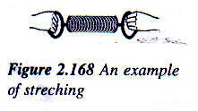
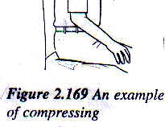
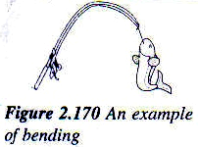
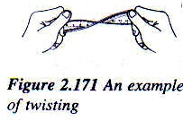
1. A force can change the size and the shape of an object in various ways: stretching, compressing, bending and twisting.

- When the force is removed, the object is able to restore back to its original size and shape. This property of matter is known as elasticity.
- Materials that return to their original shape after being bent, squashed or stretched are said to be elastic.
- The elasticity of solids is due to the strong intermolecular forces between the molecules of the solid.
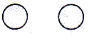

  - No external force is applied. Molecules are at their equilibrium separation. Intermolecular force is equal to zero. [When no external force is applied on the solid, the molecules are at their equilibrium separation and there is no resultant intermolecular force.]

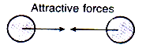

  - Stretching a solid causes its molecules to be displaced away from each other. Attractive intermolecular force acts. [When the solid is stretched, the molecules are displaced away from one another. A strong attractive intermolecular force acts between the molecules to oppose the stretching.]


  - Compressing a solid causes its molecules to be displaced closer to each other. Repulsive intermolecular force acts. [When the solid is compressed, the molecules are pushed closer to one another. A strong repulsive intermolecular force acts between the molecules to oppose the compression.]

    - Hooke’s Law
- Hooke’s law state that the extension of a spring is directly proportional to the applied force provided the elastic limit is not exceeded.
- The elastic limit of a spring is defined as the maximum force that can be applied to a spring such that the spring will be able to be restored to its original length when the force is removed.
- If a force stretches a spring beyond its elastic limit, the spring will be unable to return to its original length even though the force no longer acts on it. The length of the spring is longer than the original length. The spring is said to have a permanent extension.
- For a spring that obeys Hooke’s law,
$Fαx$
Where F = Force on the spring,
x = Extended length – Original length (extension)
Therefore
$F=\text{kx}$
Where k = Force constant of the spring
Example 2.12.1:
A spring has a force constant of 25$N{\text{cm}}^{−1}$. What is the force that will cause a 3cm extension of the spring?
Solution:
Force constant, k = 25$N{\text{cm}}^{−1}$, extension, x = 3 cm
F = kx = 25 3 = 75 N

    - Systems of Springs
- Two springs can be connected in series or in parallel.
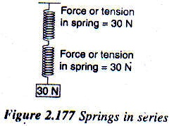

- When two springs are connected in series, the applied force acts on each of the springs. Figure above shows a system consisting of two springs in series. The force due to the 30 N load acts along the systems such that each spring experiences a force or tension of 30 N.
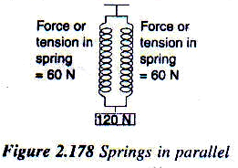

- When two springs are connected in parallel, the applied force is shared equally among the springs. Figure above shows a system consisting of two springs in parallel. The force due to the 120 N load is shared by the springs. Therefore, the tension in each spring is 60 N.

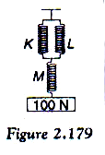
Example 2.12.2:
Figure shows three identical springs supporting a 100 N load.
State the tension in each of the spring.
Solution:
Spring K and L are parallel to each other and they are in series with spring M.
The force due to the 100 N load acts along the system.
Spring K and L share the load of 100 N
Tension in spring K = $\frac{\text{100}}{2}=\text{50}N$
Tension in spring L = $\frac{\text{100}}{2}=\text{50}N$
Tension in spring M = 100 N

Example 2.12.3:
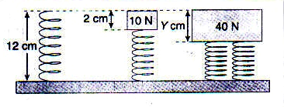
Figure shows identical springs. What is the value of Y?

Solution:
Forces on the spring = 10 N,
Compression of the spring = 2 cm
$F=\text{kx}$, $k=\frac{F}{x}=\frac{\text{10}}{2}=5N{\text{cm}}^{−1}$
Two springs share the load of 40 N.
Forces on each spring = $\frac{\text{40}}{2}=\text{20}N$
$F=\text{ky}$, $\text{20}=5×y$ $y=4$
Therefore, compression is 4 cm.

    - Elastic Potential Energy
- When a force is applied to extend a spring:
  - The magnitude of the force increases the extension increases.
  - There is a displacement in the direction of the force equal to the extension.
- When a force extends a spring, work is done because the force moves through a distance.
Area under the graph
= elastic potential energy
Extension, x
gradient, k
Force, F

- The work done on the spring, $W=\text{Average}\text{force}×\text{Extension}$
$W=\left(\frac{0+F}{2}\right)x=\frac{1}{2}\text{Fx}$
- The work done on the spring is the energy transferred to the spring and stored as elastic potential energy.
- Elastic potential energy stored in a stretched spring, $E_{P}=\frac{1}{2}\text{Fx}$.
- From Hooke’s law, $F=\text{kx}$
Therefore, $E_{P}=\frac{1}{2}\left(\text{kx}\right)x=\frac{1}{2}{\text{kx}}^{2}$
- The elastic potential energy stored in a stretched spring is also given by $E_{P}=\frac{1}{2}{\text{kx}}^{2}$.

Example 2.12.4:
A 2 kg load is hung from the end of a spring with a force constant of 160 ${Nm}^{−1}$.
(a) What is the tension in the spring?
(b) What is the extension of the spring?
(c) Calculate the elastic potential energy stored in the spring.
[Assume g = 10${ms}^{−1}$]
Solution:
- Tension in the spring = Weight of the 2 kg load
= $m×g=2×\text{10}=\text{20}N$
- Force constant, $k=\text{160}{Nm}^{−1}$, Force, $F=\text{20}N$
$F=\text{kx}$, $x=\frac{F}{k}=\frac{\text{20}}{\text{160}}=0\text{.}\text{125}m=\text{12}\text{.}5\text{cm}$
- Elastic potential energy, $E_{P}=\frac{1}{2}{\text{kx}}^{2}=\frac{1}{2}×\text{160}×0\text{.}{\text{125}}^{2}=1\text{.}\text{25}J$

    - Force – Extension Graph
- When a spring that obeys Hooke’s law is not stretched beyond its elastic limit, the force – extension graph is a straight line passing through the origin.
Extension, x
Force, F

- The force is directly proportional to the extension.
- The gradient of the graph is equal to the force constant of the spring.
- The area under the graph is equal to the work done to extend the spring. It is also the elastic potential energy stored in the spring.

- Figure below show the force – extension graphs for two different springs.
(a)
Elastic limit
Extension, x
Force, F
- Obeys Hooke’s law up to elastic limit.
- Does not obey Hooke’s law when the elastic limit is exceeded.

(b)
Extension, x
Force, F

- Does not obey Hooke’s law at all.

    - Factors That Affect Elasticity
- Springs come in different sizes and have different stiffness. The spring in a stapler is very small in size compared to the spring in the suspension system of a car. The kitchen weighing scale has a soft spring while the balance used at a wholesale fish market has a very stiff spring.
- Springs are found in simple and cheap devices such as a ball pen. You can fins springs in expensive precision instrument like electrical meter.
- Some springs are more elastic than others.
- The factors that affects the elasticity of a spring can be summarized as follows:

Factor | Change in Factor | How it Affects the Elasticity
Length | Shorter spring | Less elastic
 | Longer spring | More elastic
Diameter of spring wire | Smaller diameter | More elastic
 | Larger diameter | Less elastic
Diameter of spring | Smaller diameter | Less elastic
 | Larger diameter | More elastic
Type of material | Springs made of different materials | Elasticity changes according to the type of material

    - Applications of Elasticity
- The elastic property of matter has a wide rage of use.
- The applications of springs are as follows:
  - Springs are used in some exercise machines. The stiffness of the machine can be increased by adding more spring in parallel.
  - The traditional baby’s cradle uses one or two springs.
  - Weighing scales use springs that obeys Hooke’s law. A weighing scale with a smaller rage uses a softer spring. For example, a 0 – 1 kg weighing scale uses a softer spring than 0 – 20 kg weighing scale.
  - Moving coil ammeters and voltmeters use control springs to stop the deflection of the pointer. The springs bring the pointer back to zero position when the circuit is disconnected.
  - Springs mattress have many small springs arranged side by side to support the weight of the person on it.
  - Springs from part of the suspension system of vehicle. The springs are repeatedly compressed during a journey.
- Applications that make use of the elastic property of materials:
  - Sponge mattress is relatively cheap and light. The sponge is compressed when a person on the mattress.
  - Bulldog paper clips open u when a force is applied. It grips the paper tightly when the spring tries to return to its original shape.
  - The pole used by an athlete in a pole vault event is elastic. It bends under the weight of the athlete but later becomes straight again after the weight is removed.
  - The headphone has a curved metal strip that is elastic so that it can grip around a person’s head.

