Science 55/1
Paper 1
May
2005
1 hour

SCIENCE DEPARTMENT

SMJK HUA LIAN TAIPING

MID YEAR EXAMINATION 2005

SCIENCE

Paper 1

One hour

DO NOT OPEN THIS BOOKLET UNTIL YOU ARE TOLD TO DO SO

- This question paper consists of 40 questions.

- Answer all questions.

- Answer each question by blackening the correct space on the answer sheet.

- Blacken only one space for each question.

- If you wish to change your answer, erase the blackened mark that you have made. Then blacken the space for your new answer.

- The diagrams on the questions provided are not drawn to scale unless stated.

- You may use a non-programmable scientific calculator.

This question paper contains 14 printed pages.

55/2 ©haling⌐ÓζÒ¬2005®™ [Turn over

1. | Science is knowledge
 | A. | about living things.
 | B. | discovered by the scientists.
 | C. | that can explain natural phenomena.
 | D. | on how to invent new things.

2. | Which of the following is a laboratory safety rule ?
- Food and drinks are prohibited in the science laboratory.
- Students are not allowed to go into the science laboratory without the teacher’s permission.
- All apparatus and chemicals are to be used as instructed by teacher.
- Do not report any minor injury to the teacher.

 | A. | I and II only.
 | B. | I, II and III only.
 | C. | II, III and IV only.
 | D. | All of the above.

3. | What is the relationship between science and technology ?
 | A. | Science is a knowledge obtained from technological research.
 | B. | Technology is a knowledge obtained from scientific research.
 | C. | Science is the application of technological ideas,
 | D. | Technology is the application of scientific ideas.

4. | Which of the following courses is correctly matched with the knowledge acquired ?
 |  | Course |  | Knowledge
A |  | Geology |  | A study of the earth, people and climate.
B |  | Geography |  | A study of rock and minerals.
C |  | Physics |  | A study of planning and construction of buildings and bridges.
D |  | Meteorology |  | A study of weather.

P - Making hypothesis
Q - Interpreting and analyzing data
R - Identifying problem
S - Planning experiment
T - Making conclusion

5. | The information box above consists of procedures involved in scientific method. Which of the following shows the correct sequence for the mentioned procedures ?
 | A. | P, Q, R, S, T
 | B. | Q, R, S, T, P
 | C. | R, P, S, Q, T
 | D. | P, S, Q, R, T

Questions no. 6 and 7 are based on the following diagram.


6. | What is the meaning of this hazard warning symbol ?
 | A. | Irritant
 | B. | Poisonous
 | C. | Corrosive
 | D. | Explosive

7. | What are the examples of substances labeled with this hazard warning symbol ?
 | A. | Mercury and sodium cyanide
 | B. | Chloroform and ammonia
 | C. | Sodium and potassium
 | D. | Ethanol and kerosene  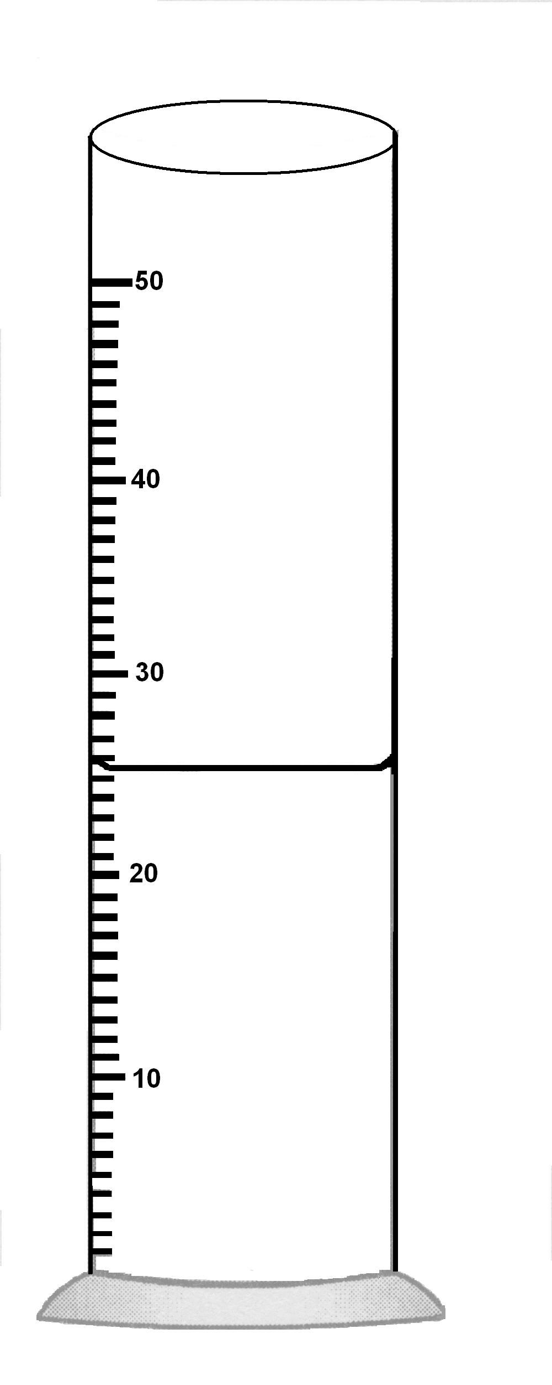

The diagram shows a measuring cylinder containing liquid.

8 | What is the volume of the liquid ?
 | A. | 25.0 ml
 | B. | 25.5 ml
 | C. | 26.0 ml
 | D. | 26.5 ml

9. | Yi Ping sets up an experiment to determine if the length of the pendulum will affect the period of swing. Which of the following variables are correctly used ?  - Manipulated variable : length of pendulum  - Constant variable : weight of pendulum  - Responding variable : time of swing of pendulum
 | A. | I and II only
 | B. | I and III only
 | C. | II and III only
 | D. | I, II and III

10. | What is the meaning of the prefix Mega ?
 | A. | 10 000
 | B. | 100 000
 | C. | 1 000 000
 | D. | 1 000 000 000

11. | 1 378 m is equivalent to…
 | A. | 1.378 km
 | B. | 13.78 km
 | C. | 137.8 km
 | D. | 1 378 km

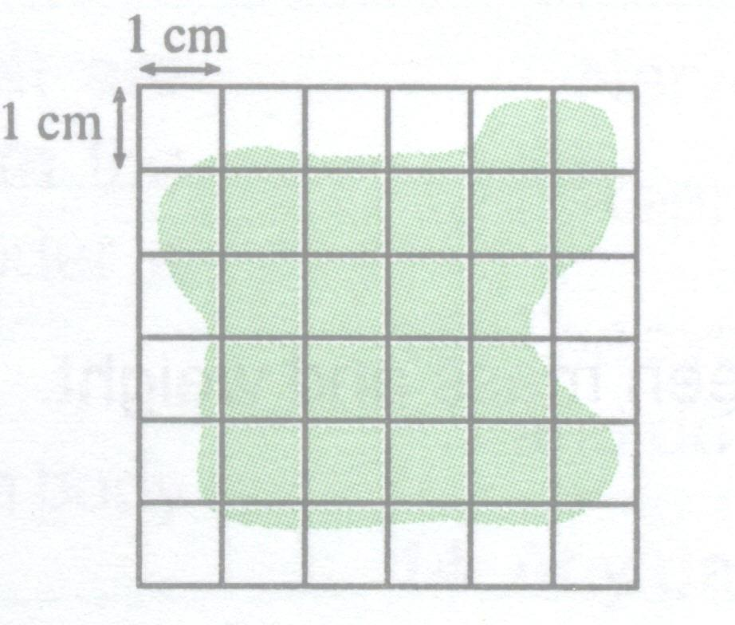

12 | What is the estimated area of the irregular shape shown above ?
 | A. | 19 cm³
 | B. | 21 cm³
 | C. | 24 cm³
 | D. | 27 cm³

13. | Which of the following is used to measure the volume of a cork stopper ?  I measuring cylinder  II thread  III small stone  IV water
 | A. | I and IV only
 | B. | I, II and IV only
 | C. | I, III and IV only
 | D. | I, II, III and IV

14. | Which of the following instruments is the most suitable to measure the weight of an object ?
 | A. | 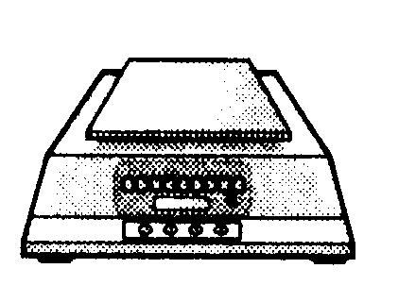
 | B. | 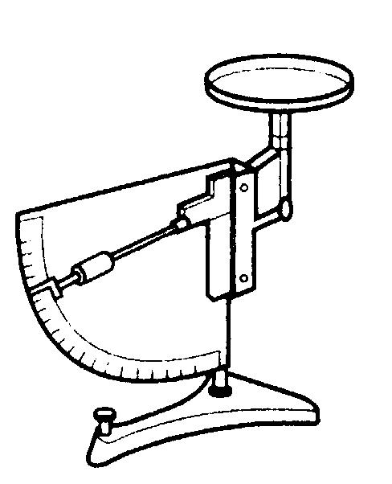
 | C. | 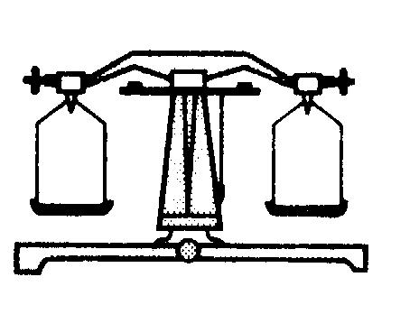
 | D. | 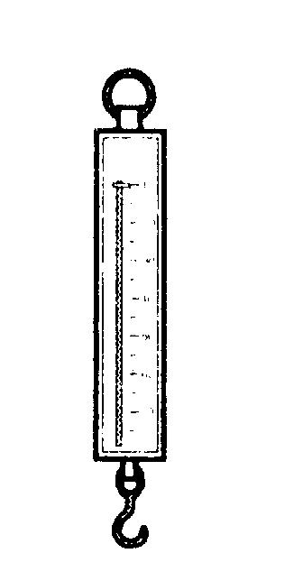

15. | Which of the following apparatus is used for measuring the volume of liquids ?
I pipette
II burette
III measuring tape
IV measuring cylinder

 | A. | I and III only
 | B. | II and III only
 | C. | I, II and IV only
 | D. | I, II, III and IV

Questions 16 and 17 based on the diagram below.
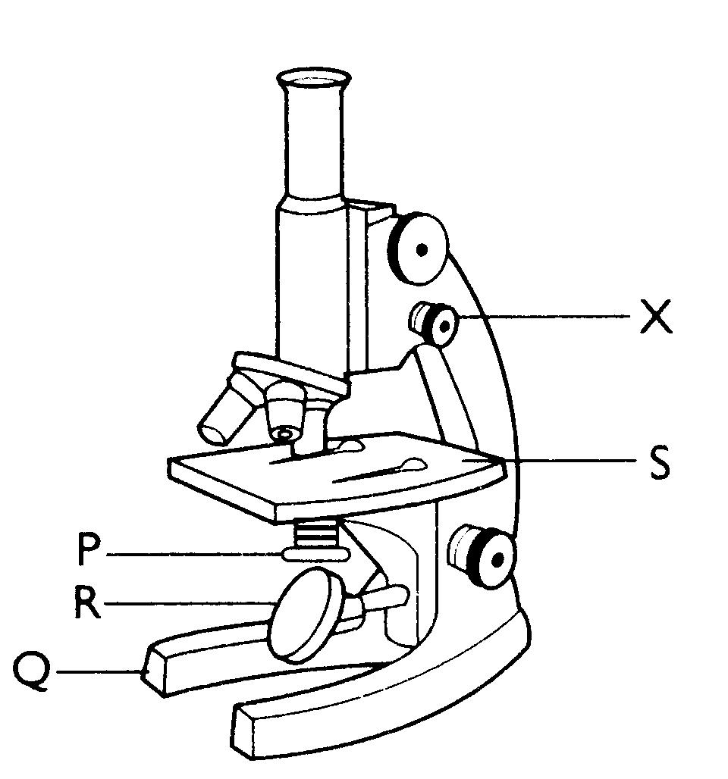

16. | The above diagram shows a microscope which is used to observe microorganisms in a laboratory. The function of the part labeled X is to
 | A. | move the glass slide from left to right.
 | B. | enlarge the image of the specimen.
 | C. | adjust the objectives lens in order to get a clearer image.
 | D. | Control the intensity of light.

17. | The part of the microscope which reflects light to the specimen is ..
 | A. | P
 | B. | Q
 | C. | R
 | D. | S

W : Cover the specimen with a cover slip.

X : Dry the slide and the cover slip.

Y : Make sure there are no air trapped in the slide.

Z : Place a drop of iodine solution on the specimen.

18. | The information above show the steps in the preparation of prepared slide in the laboratory. The correct order for the steps should be
 | A. | W → Z → X → Y
 | B. | W → Y→ X → Z
 | C. | Z → W →Y → X
 | D. | Z → Y → W→ X

19. | Which of the following structure of the cell is NOT matched correctly to its function ?
 |  | Structure Function
 | A. | Nucleus Control all activities in a cell
 | B. | Cell membrane Control the movement of materials in and out of a cell
 | C. | Cytoplasm Transporting of material to all parts of the cell
 | D. | Vacuole Store dissolved materials and water

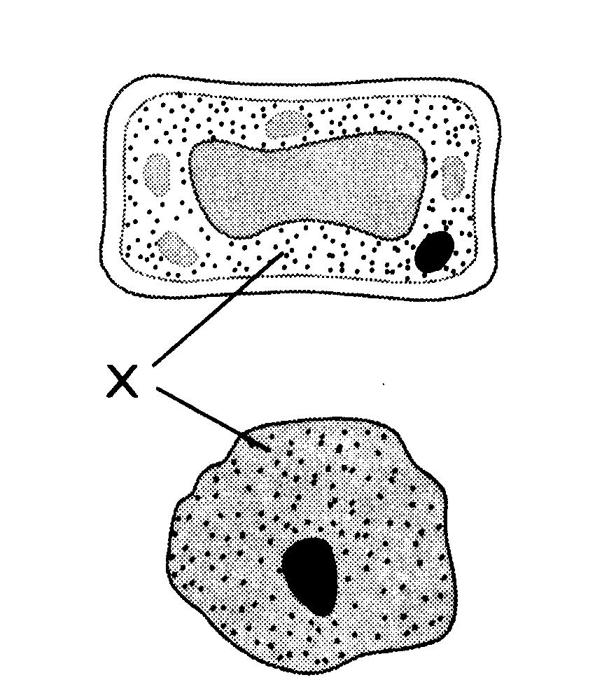
20. | The above diagram shows the structure of a plant cell and an animal cell. State the function of the part labeled X .
 | A. | To control the cell activities.
 | B. | To store food in the form of solution.
 | C. | To protect and maintain the shape of the cell.
 | D. | To contain chlorophyll that absorbs light during photosynthesis.

21. | Which of the following organisms represents a multicellular organism ?
 | A. | 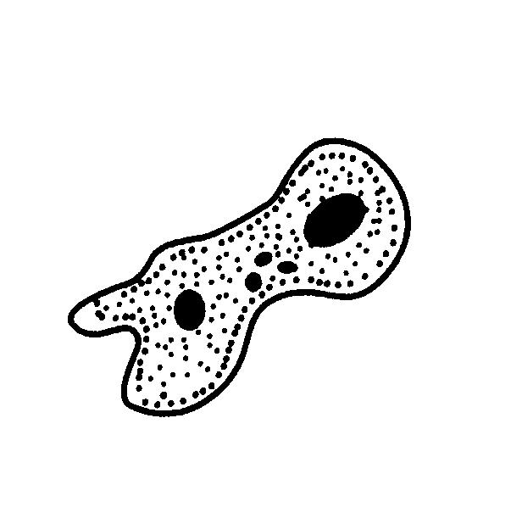
 | B. | 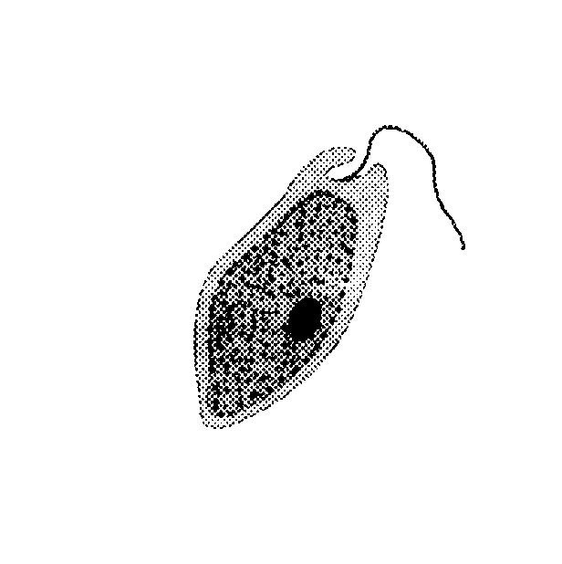
 | C. | 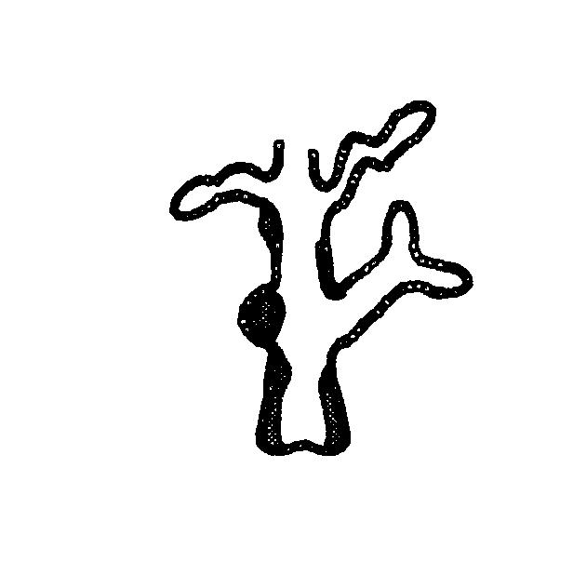
 | D. | 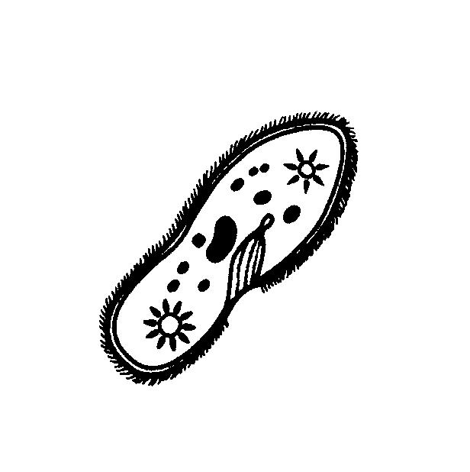

22. | Which of the following is made up of two or more tissues in human beings ?  - Lungs  - Stomach  - Brain  - Heart
 | A. | II only
 | B. | I and III only
 | C. | II, III and IV only
 | D. | I, II, III and IV

23. | Which of the following cells transport oxygen in the body ?
 | A. | 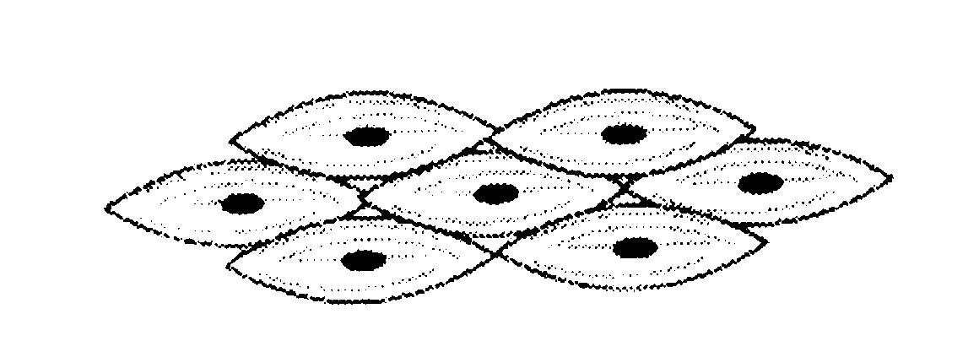
 | B. | 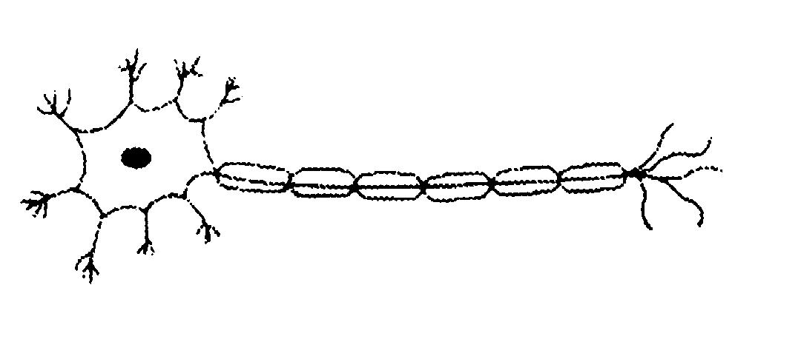
 | C. | 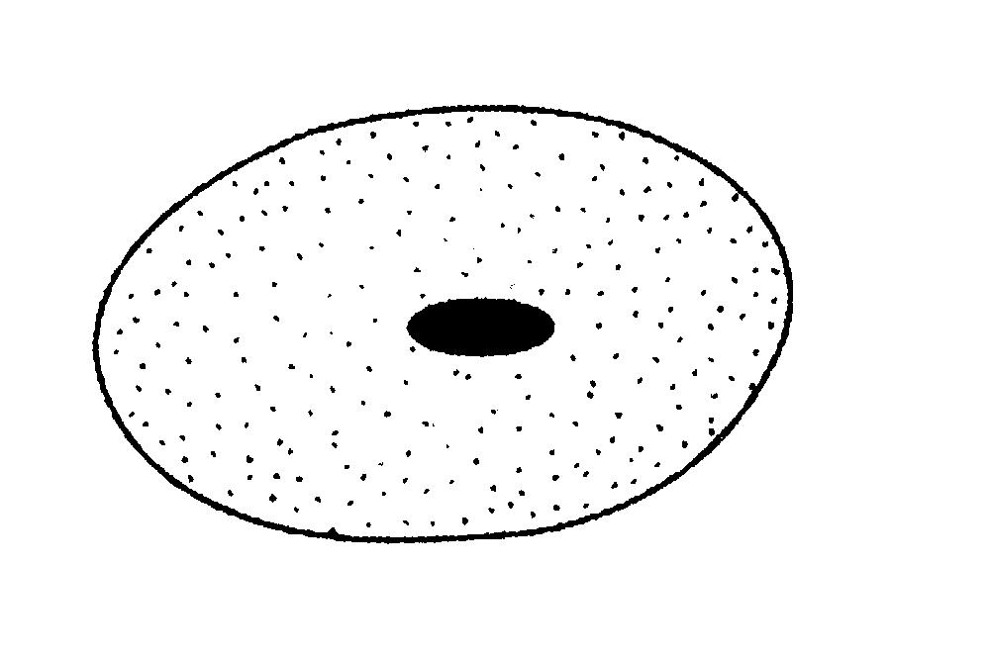
 | D. | 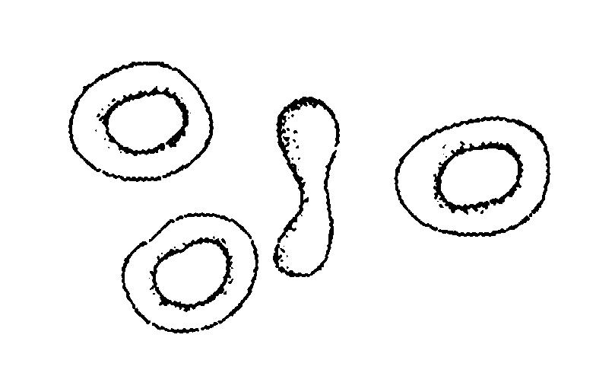

Kidneys
Liver
System X

24. | The above diagram shows parts of the system X. What is the function of the system X ?
 | A. | To detect external stimuli.
 | B. | To digest and absorb food.
 | C. | To carry oxygen, food and waste products.
 | D. | To excrete excess water, urea and mineral salts.

25. | 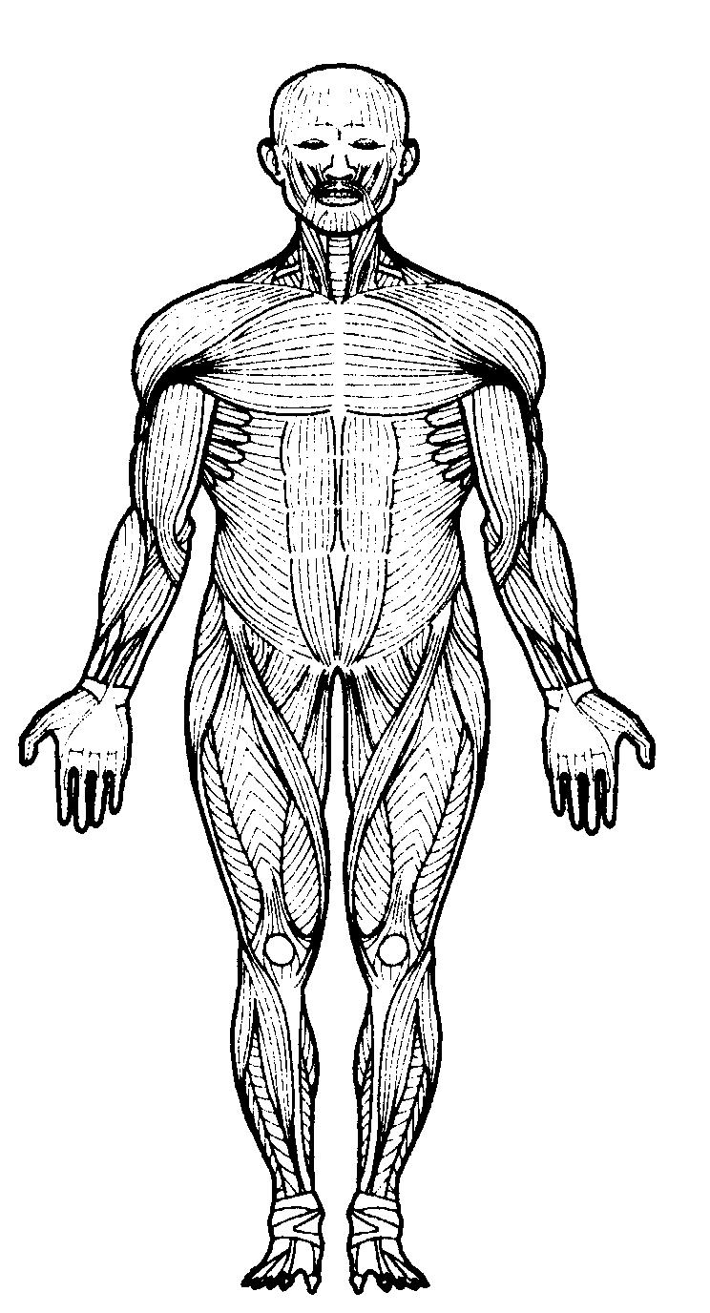  Which of the statements are true about the system in the human body shown in the diagram above ?  - The organized system is attached to the skeleton.  - The organ involved is the tendon.  - This system brings about the movement of bones
 | A. | I only
 | B. | I and II only
 | C. | II and III only
 | D. | I, II and III

V
W
Organ
X

26. | If the organ in the diagram above is ovary, what is X ?
 | A. | The digestive system
 | B. | The reproductive system
 | C. | The respiratory system
 | D. | The excretory system

- Cover the surface of the body.

- Protect the cells below them.

27. | Identify the cells that are related to the information given above.
 | A. | Muscle cells
 | B. | Epithelial cells
 | C. | White blood cells
 | D. | Nerve cells

28. | Which of the following characteristics of human beings differentiate them from animals ?  - Can speak and endowed with feelings.  - Able to differentiate between good and bad.  - Able to think logically
 | A. | I and II only
 | B. | I and III only
 | C. | II and III only
 | D. | I, II and III

29. | What will happen if there is no cell organization in the human body ?  - The responsibilities of each cell will increase to perform all the life process simultaneously.  - No division of labour occur among the cells.  - All life process can be performed effectively.
 | A. | I, II and III
 | B. | I and II only
 | C. | II and III only
 | D. | I and III only

30. | In which of the following are the systems and functions correctly matched ?  - Digestive system : break down food into simple substance for absorption.  - Muscular system : receives and carries information to all parts of the body.  - Respiratory system : transport oxygen to and removes carbon dioxide from our body cells.  - Skeletal system : supports the body and provides protection for the organs.
 | A. | I and II only
 | B. | I, II and III only
 | C. | I, III and IV only
 | D. | I, II, III and IV

31. | The figure shows the arrangement of particles of substance.  Which of the following substances has such arrangement of particles ?
 | A. | Air
 | B. | Steam
 | C. | Iron rod
 | D. | Cooking oil

32. | Which of the following are the characteristics of chlorine gas ?  - The particles collide with one another.  - The forces of attraction between particles are very weak.  - The particles are far apart and have a disorderly arrangement.
 | A. | I and II only
 | B. | I and III only
 | C. | II and III only
 | D. | I, II and III

33. | The diagram above shows the Brownian movement of smoke particles that are seen through a light microscope. The particles move randomly because…
 | A. | air particles collide with the smoke particles.
 | B. | air particles move faster than smoke particles.
 | C. | air particles react with smoke particles.
 | D. | there are forces of attraction between the smoke particles.

P : Its particles move at random and it has no fixed volume.

Q : Its particles vibrate in fixed positions and it has a definite volume.

34. | The statement above describe the characteristics of two types of matter. What do P and Q represent ?
 |  | P Q
 | A. | Water Nitrogen
 | B. | Nitrogen Copper
 | C. | Mercury Iron
 | D. | Copper Water

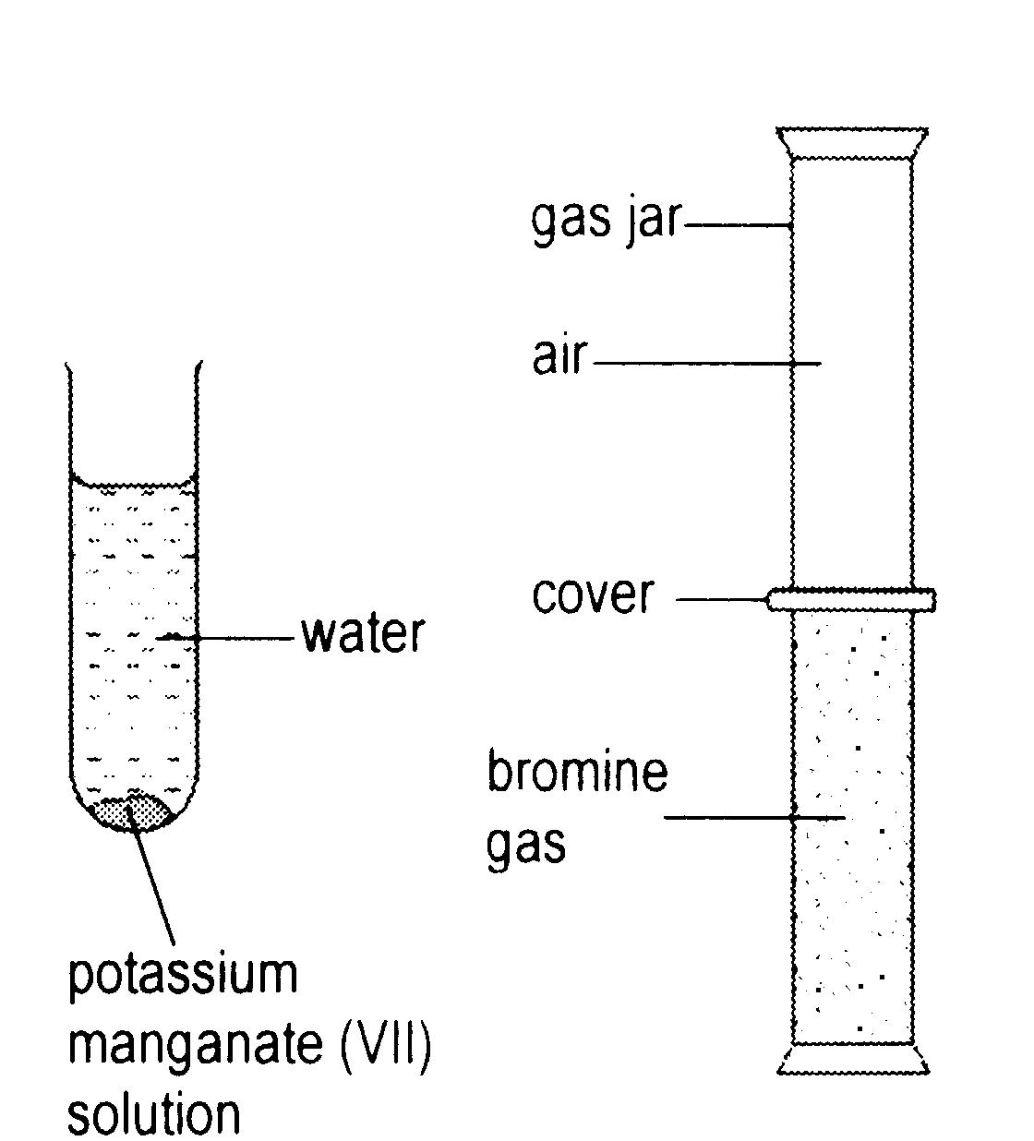

35. | Diagram above shows the apparatus set up by Chai Sze to compare the rate of diffusion of a bromine gas in air with rate of diffusion of potassium manganate (VII) through water. Which statements are true about the experiment ?  - The rate of diffusion of bromine gas is faster than the rate of diffusion of potassium manganate (VII) through water.  - The spaces between liquid particles are smaller than the spaces between gas particles.  - The gas particles are bigger than the liquid particles.
 | A. | I and II only
 | B. | I and III only
 | C. | II and III only
 | D. | I, II and III

36. | A stone has a mass of 10 g . It is put into a jar which contains 80 ml of water. Then the water level increases to 100 ml. What is the density of the stone ?
 | A. | 0.05 g/ml
 | B. | 0.1 g/ml
 | C. | 0.5 g/ml
 | D. | 2.0 g/ml

37. | Which of the following involves the use of the concept of density ?  - Buoy  - Hot air balloon  - Float  - Ship
 | A. | I and II only
 | B. | I , II and III only
 | C. | I, II. III and IV
 | D. | IV only

Liquid | Density (g cm³)
P | 13.6
Q | 1.0
R | 0.8

38. | Table above shows liquids with different densities contained in a measuring cylinder. Which of the following shows the correct position of P, Q and R ?
 | A. | 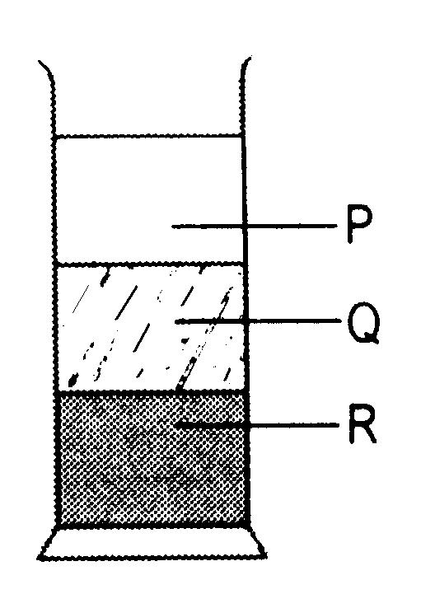
 | B. | 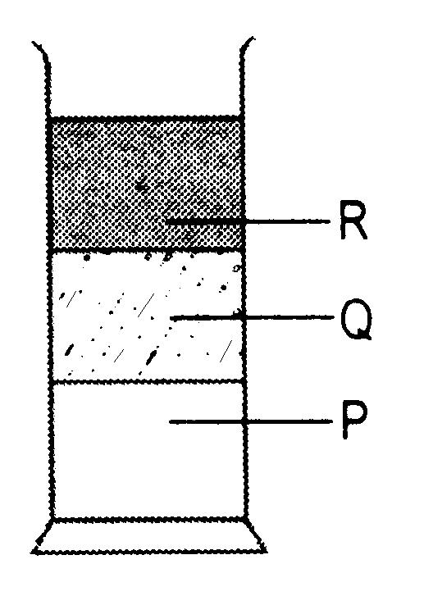
 | C. | 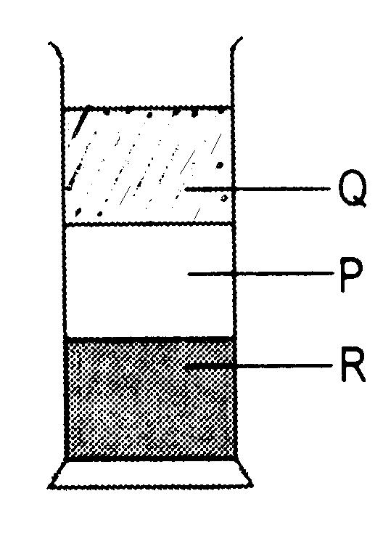
 | D. | 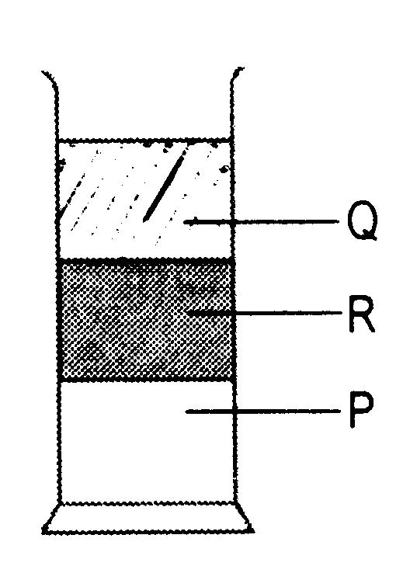

39. | Which of the following daily activities does not involve evaporation ?
 | A. | Producing salt from sea water.
 | B. | Drying up clothes on clothes line.
 | C. | Drying fish so that it can last longer.
 | D. | Burning a candle.

40. | Which of the following characteristics of matter benefit mankind ?  - Ice is used to build igloo  - The natural water cycle.  - The cooling process of the air conditoners
 | A. | I only
 | B. | I and II only
 | C. | I and III only
 | D. | I, II and III

END OF QUESTION PAPER

