SMJK PEI YUAN , KAMPAR
MONTHLY TEST (MARCH 2009)
FORM FIVE
ADDITIONAL MATHEMATICS
Time: 1 hour

NAME : …………………………………… CLASS :…………… MARKS :…............

1. Given p+5, 2p-1 and p+1 are the three consecutive terms of an arithmetic progression,find the value
of p.

Answer | : P = 4
Topic | : Progression (Arithmetic Progression)
Learning Objective | : Understand and use the concept of arithmetic progression.
Construct | : Knowledge
Level | : Low

2. The sum of the first n terms of an arithmetic progression by S_{n} = n² – 9n. Find
a) the first term,
b) the sum of the first 11 terms,
c) the 11th term of the arithmetic progression.

Answer | : a) -8 b) 22 c) 12
Topic | : Progression (Arithmetic Progression)
Learning Objective | : Understand and use the concept of arithmetic progression.
Construct | : Understanding
Level | : Medium

3. What is the number of the term in the geometric progression 0.9, 2.7, 8.1, …..,656.1?

Answer | : 7
Topic | : Progression (Geometric Progression)
Learning Objective | : Understand and use the concept of geometric progression.
Construct | : Understanding
Level | : Medium

4. For a geometric progression, the first term is 21 and the 5th. term is $\frac{7}{\text{27}}$ . Find
a) the common ratio,
b) the sum to infinity of the geometric progression.

Answer | : a) $\frac{1}{3}$ b) $\text{31}\frac{1}{2}$
Topic | : Progression (Geometric Progression)
Learning Objective | : Understand and use the concept of geometric progression.
Construct | : Knowledge
Level | : Medium

5. Diagram below shows a straight line graph of $\frac{y}{x}$ against x.
$$\frac{y}{x}$$

x (2,k)

x(h,3)

$$x$$
0

Given that y = 6x – x², calculate the value of k and of h.
``

Answer | : k = 4 , h = 3
Topic | : Linear Law
Learning Objective | : Apply linear law to non linear relations.
Construct | : Understanding
Level | : Low

6. The variables x and y are related by the equation y = kx⁴, where k is a constant.
a) Convert the equation y = kx⁴ to a linear form.
b) Diagram below shows the straight line obtained by plotting log₁₀ y against log₁₀ x.
log${}_{\text{10}}$y

x (2,h)

x (0,3)
$${\text{log}}_{\text{10}}x$$

0

Find the value of
a) k.
b) h

Answer | : a) k = 1000 b) h = 11
Topic | : Linear Law
Learning Objective | : Apply linear law to non linear relations.
Construct | : Understanding
Level | : Medium

7. Diagram below shows part of an arrangement of bricks of equal size.

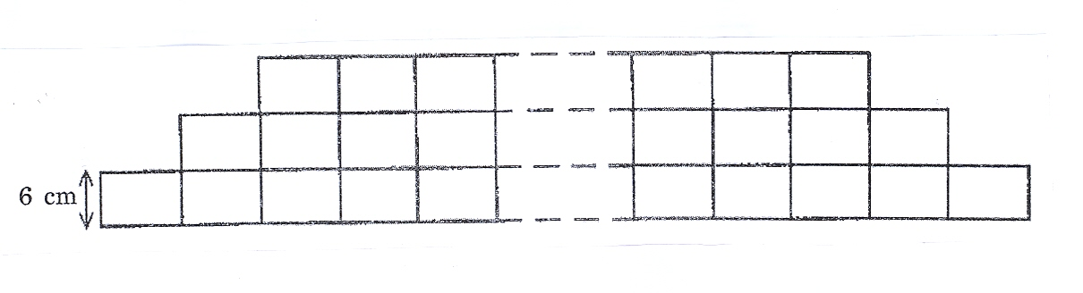
The number of bricks in the lowest row is 100. Foe each of the other rows, the number of bricks is 2 less than in the row below. The height of each brick is 6 cm.
Ali builds a wall by arranging bricks in this way. The number of bricks in the highest row is 4. Calculate

- the height, in cm. of the wall.
- The total price of the bricks used if the price of one brick is 40 sen.

Answer | : a) 294 cm b) RM 1,019.20
Topic | : Progressions (Arithmetic Progression)
Learning Objective | : Understand and use the concept of arithmetic progression.
Construct | : Application
Level | : High

8. An organization has pledged to donate to a welfare home each year staring from 2006. The amount in
2006 is RM 10,000 and thereafter is 90% of the amount of each preceding year. Find

- the year in which the value of the donation first falls below RM 2000.
- The number of years when the total amount donation first exceeds RM 80,000.

Answer | :a) year 2022 b) 16 years
Topic | : Progression (Geometric Progression)
Learning Objective | : Understand and use the concept of geometric progression.
Construct | : Application
Level | : High

9. Table below shows the values of two variables, x and y, obtain from an experiment. The variable x and
y are related by the equation y = px + $\frac{r}{\text{px}}$ , where p and r are constants.

x | 1.0 | 2.0 | 3.0 | 4.0 | 5.0 | 5.5
y | 5.5 | 4.7 | 5.0 | 6.5 | 7.7 | 8.4

- Plot xy against x², by using a scale of 2 cm to 5 units on both axes. Hence, draw the line of best fit.
- Use the graph from (a) to find the value of
  - p.
  - r.

Answer | : $p≈1\text{.}\text{41}$ , $r≈4\text{.}\text{57}$
Topic | : Linear Law
Learning Objective | : Apply linear law to non linear relations.
Construct | : Application
Level | : High

_____________________________________________________________________________________

This paper is prepared by Checked by Approved by

……………………….. …………………….. …………………......
(Mdm. Tan Chiew Nai) (Mr. Ng Mooi Long ) (Mr. Lai Kok Chew)
(Panel Head of Add. Maths) (Senior Assistant)

