 | Introduction - Energy from Matter  E=mc²  Einstein's famous equation from 1905 E=mc² demonstrates that energy (E) is equivalent with matter (mass m). It suggests that the concept of mass is indeed, less basic than what can be believed from everyday experiences with massive bodies. In fact, energy can be transformed into massive particles, and mass can be transformed into energy. Energy in all its different appearances is a key concept in physics.  The Nucleus  The atomic nucleus is made up of protons (charge +1) and neutrons (neutral). A light nucleus like helium (He) consists of two protons and two neutrons. A typical medium-sized nucleus is tin, with 50 protons and 69 neutrons. Uranium is a heavy nucleus with 92 protons. One of the different uranium nuclei has 143 neutrons. This nucleus is called ²³⁵U with 235 being the sum of the numbers of protons and neutrons.
  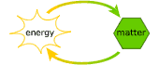
  Energy and matter are equivalent.
  The building blocks of nuclei.
  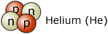
  The helium nucleus has two protons and two neutrons.
  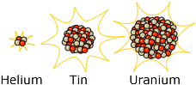
  A light, medium and heavy nucleus.
 | Binding Energy  A peculiar and very important property of the nucleus is that its mass is not the sum of the masses of the protons and neutrons that make up the nucleus, it is less! This is because the strong nuclear force binds neutrons and protons in the nucleus together and energy is required to separate them.  This energy is called the binding energy, and by E=mc² gives the nucleus less mass than the sum of the masses of its constituents. This is also the reason why many nuclei are stable. The binding energy per proton or neutron is largest for medium-sized nuclei and less for very heavy and for very light nuclei.
  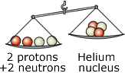
  The mass of the helium
  nucleus is less than the sum of the masses of its building blocks.

