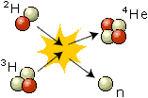 | What is Fusion?  When light nuclei are brought together to form a heavier nucleus (a process called fusion), energy is released. When a deuterium and a tritium nucleus fuse, a helium nucleus and a neutron are formed. The difference in mass between the initial and final states is transformed into an energy release of 17.6 MeV, 3.5 MeV per participating nucleon, corresponding to about 0.4% of the mass of the nuclei. The two nuclei in a fusion process must collide at very high speed to overcome the repulsion caused by the positive charges of the two nuclei.
  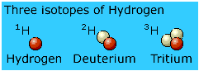
  Three isotopes of hydrogen

