SMJK KWANG HUA, KLANG
YEAR-END EXAMINATION 2009
FORM 4 PHYSICS

Name: ______________________ Form 4 ____

Answer Sheet For Section A:
1. 6. 11. 16. 21. 26.
2. 7. 12. 17. 22. 27.
3. 8. 13. 18. 23. 28.
4. 9. 14. 19. 24. 29.
5. 10. 15. 20. 25. 30.
___________________________________________________________________________
Students are not allowed to write anything in the table below!

Section | Question | Full Marks | Marks Obtained
A | 30 | 30
B | 1 | 4
B | 2 | 6
B | 3 | 8
B | 4 | 7
B | 5 | 7
B | 6 | 8
C | 1 | 8
C | 2 | 10
C | 3 | 12
Total

Section A: Objective Question (30%)
Instruction: This section consists of 30 questions. Answer all questions. Each question is followed by four options. Choose the best answer for each question and then write it on the answer sheet provided.

- Initial velocity u , final velocity v , time t and another quantity k are connected in a formula as shown :
$$v−u=kt$$

A suitable unit for k is

  - ${ms}^{−1}$ B. $m^{−1}s$ C. ${ms}^{−2}$ D. $m^{2}s^{−2}$

- Which of the following physical quantity have the same SI unit with $\frac{(\text{momentum})^{2}}{\text{mass}}$?

A Work B Force C Density D Pressure

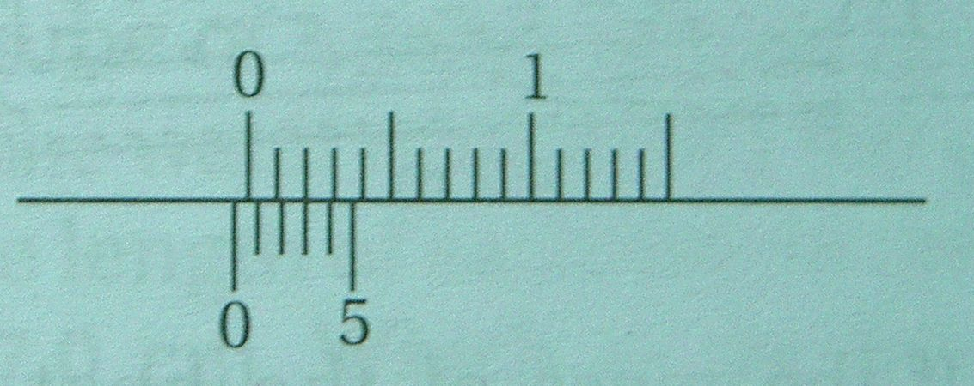

The diagram above shows the zero reading of Vernier calipers. Each measurement taken using these Vernier calipers should be corrected by

A. Adding 0.03 cm C. Adding 0.07 cm

B. Subtracting 0.03 cm D. Subtracting 0.07 cm

- The diagram shows a micrometer screw gauge with its jaws closed and opened when it is used to measure the diameter of a metal rod.
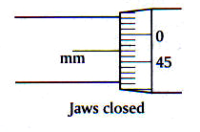
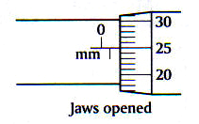

What is the radius of the metal rod?

A $0\text{.}\text{36}\text{mm}$ B $0\text{.}\text{39}\text{mm}$ C $0\text{.}\text{61}\text{mm}$ D $0\text{.}\text{78}\text{mm}$

- The graph shows the relationship between physical quantities P and Q.
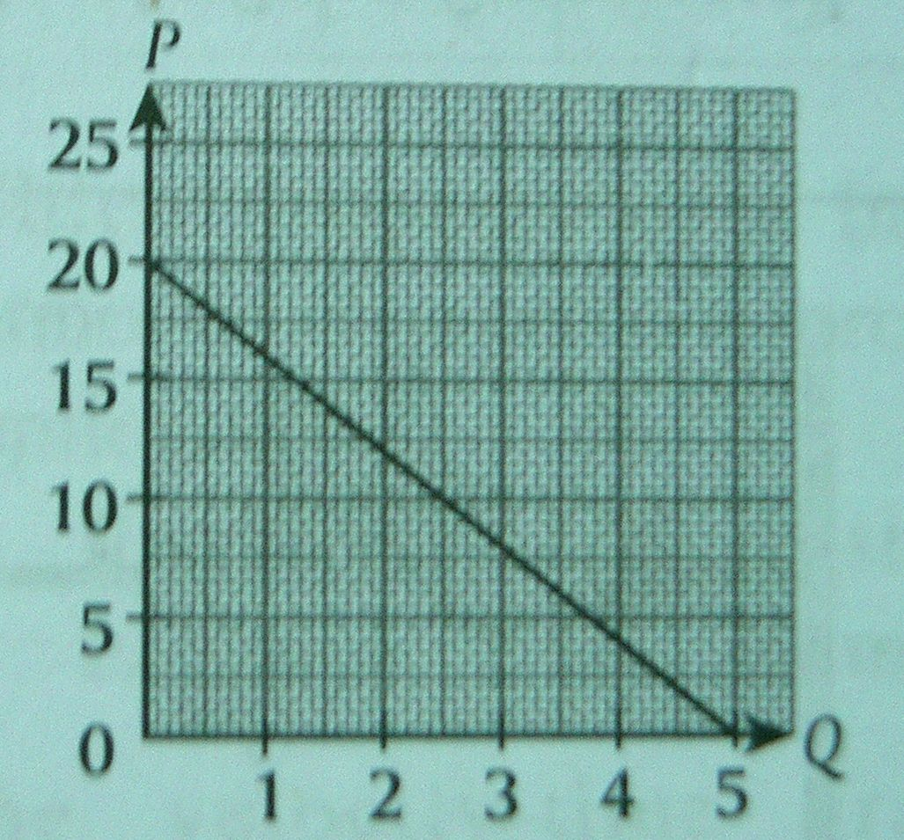

What is the linear relationship between P and Q?

A. P = 20 – 4Q C. P = 20 – 0.25Q

B. P = 4Q + 20 D. P = 0.25Q + 20

- The inertia of an object depends on the

A gravitational field strength
B temperature of the object
C velocity of the object
D mass of the object
- Figure below is a chart representing the motion of a trolley.
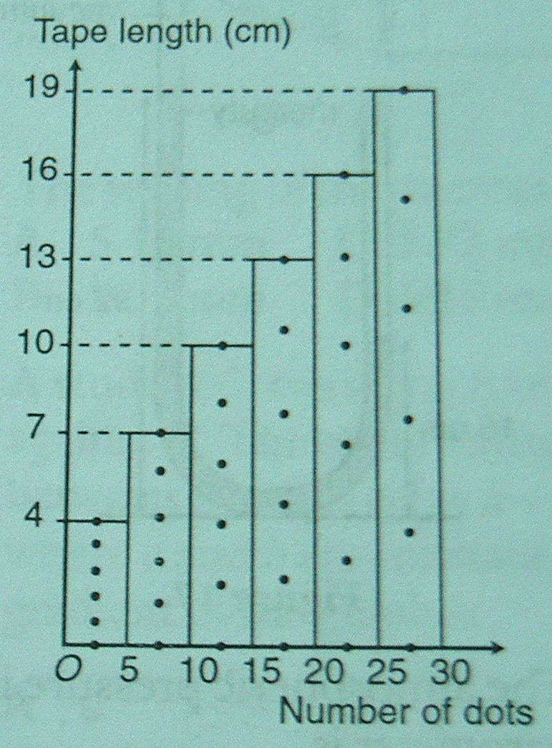

Given that the frequency of the ticker-timer is 50 Hz, what is the acceleration of the trolley?

A. 2.0 m $s^{−2}$ B. 3.0 m $s^{−2}$ C. 4.5 m $s^{−2}$ D. 5.2 m $s^{−2}$

- Figure below shows the graph of velocity (v) – time (t) of an object.
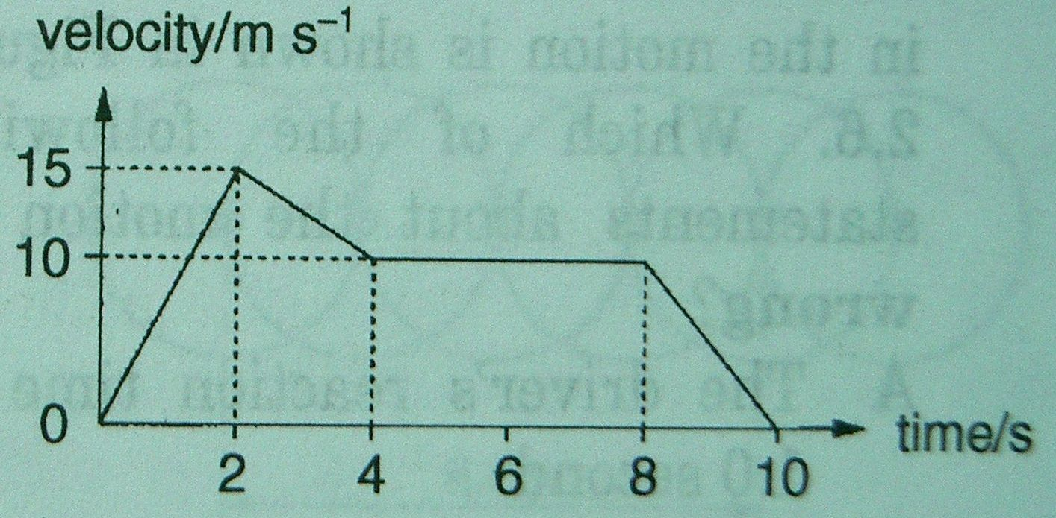

The average velocity of the object for the whole motion is

A. 1.5 m $s^{−1}$ B. 3.0 m $s^{−1}$ C. 6.0 m $s^{−1}$ D. 9.0 m $s^{−1}$

- Which of the following statements about the gravitational field of Earth is not true?

  - Weight of an object is caused by the force of gravity
  - All objects that are dropped through a vacuum from the same height will experience the same acceleration
  - The acceleration of gravity is directed towards the centre of the Earth
  - The Earth and the Moon are pulling each other but the pull from the Earth on the Moon is much stronger

- Figure shows three pieces of rope tied to a ring. Two of the ropes are pulled by 70 N forces acting at an angle of $\text{70}°$ with one another.
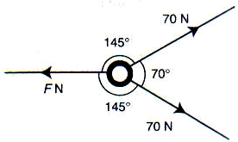

The magnitude of the force, F required to maintain the ring in equilibrium is

A. 70 N B. 115 N C. 140 N D. 156 N

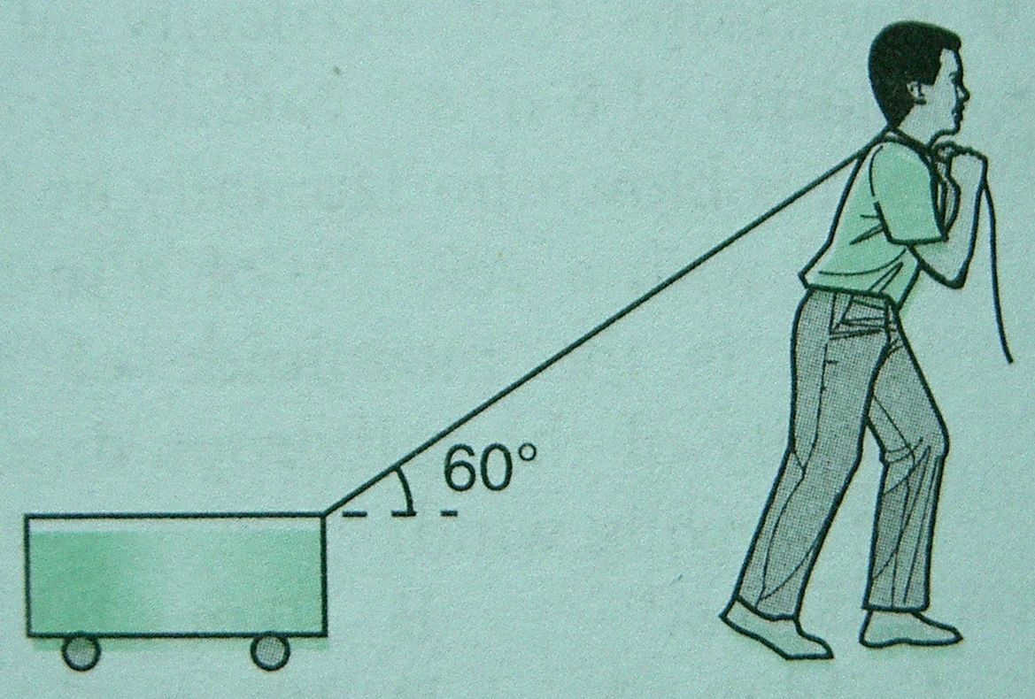
- A student is pulling a trolley with an iron chain which makes an angle of $\text{60}°$ with the horizontal.

If the tension of the string is 5 000 N, what is the horizontal force?

A. 2 500 N B. 4 330 N C. 5 000 N D. 5 500 N
- Figure shows a system of three identical springs. Each spring extends 2 cm when subjected to a load of 40 g.
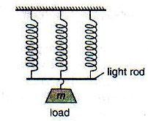

Calculate the mass of m, if the spring system in Figure extends by 4 cm.

A. 60 g B. 120 g C. 180 g D. 240 g

- The weight of an elephant is 60 000 N. It has four feet. Each foot has an area of 500 ${\text{cm}}^{2}$. What pressure does the elephant exert on the ground?

A. 1.1 ${\text{10}}^{5}$ N$m^{−2}$ C. 1.2 ${\text{10}}^{5}$ N$m^{−2}$
B. 3.0 ${\text{10}}^{5}$ N$m^{−2}$ D. 3.6 ${\text{10}}^{5}$ N$m^{−2}$

- The figure shows a container containing water.
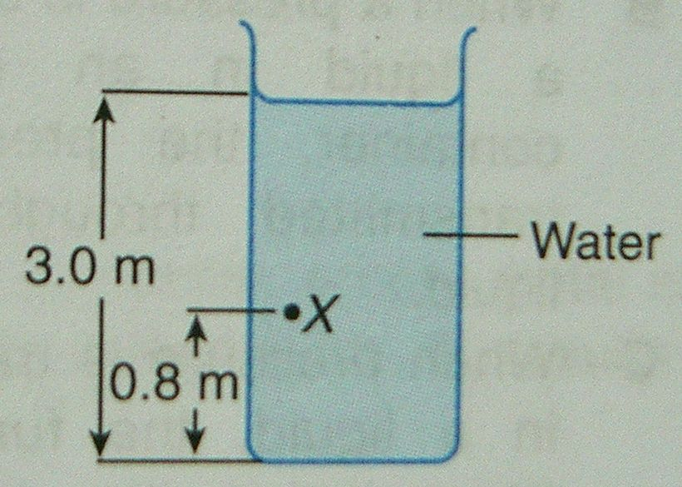

The density of water is 1 000 kg $m^{−3}$. The pressure exerted by the water at X is

A. 29 400 Pa C. 21 560 Pa
B. 27 440 Pa D. 11 760 Pa
- Figure below shows a U-tube filled with two liquids, X and Y which are immiscible.
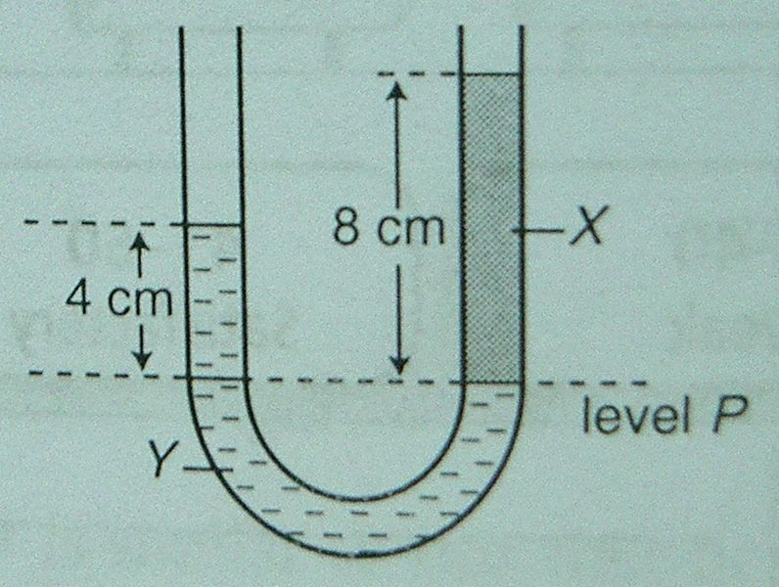

The heights of the liquid columns of X and Y from level P are 8.0 cm and 4.0 cm respectively. If the density of liquid X is 0.4 g${\text{cm}}^{−3}$, which of the following statements is true?

  - Liquid X is denser than liquid Y.
  - Liquid X and liquid Y have the same density.
  - The pressure of column X and column Y at level P are different.
  - The density of liquid Y is 800 kg$m^{−3}$.

- In figure below, the height of a mercury column in a glass tube is 50 cm.
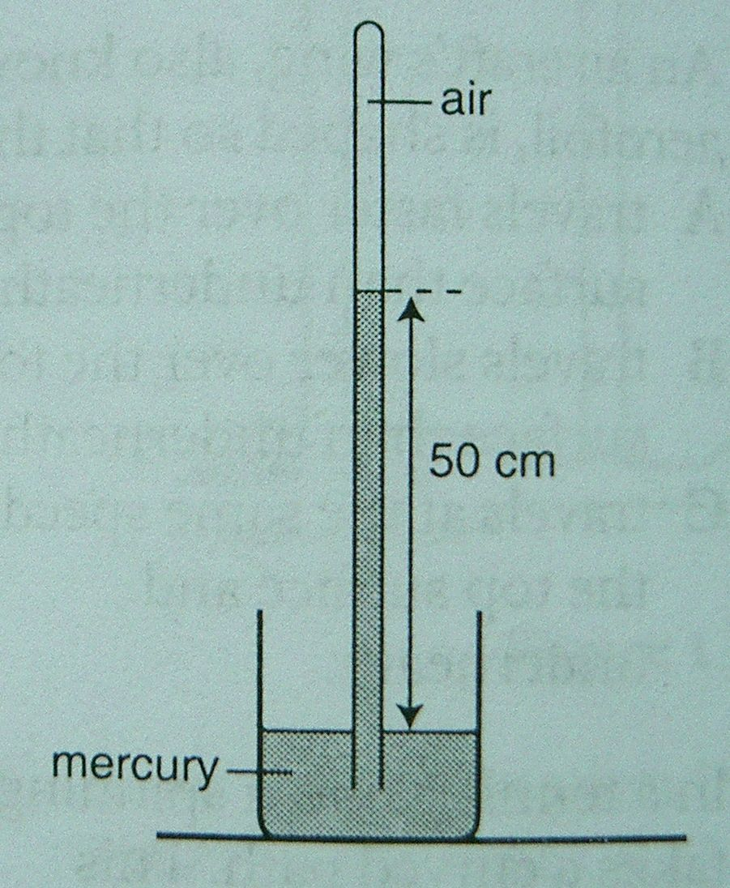

If the atmospheric pressure is 76 cm Hg, calculate the pressure of the air trapped inside the tube.
A. 26 cm Hg C. 89 cm Hg
B. 50 cm Hg D. 126 cm Hg
- The input and output pistons of a hydraulic jack are respectively 2 cm and 5 cm in diameter. How much mass can the jack lift if a force of 40 N is applied to the input piston?

A. 100 N B. 125 N C. 250 N D. 500 N

- The figure shows hydraulic systems when a 20 kg object balances a 50 kg object.
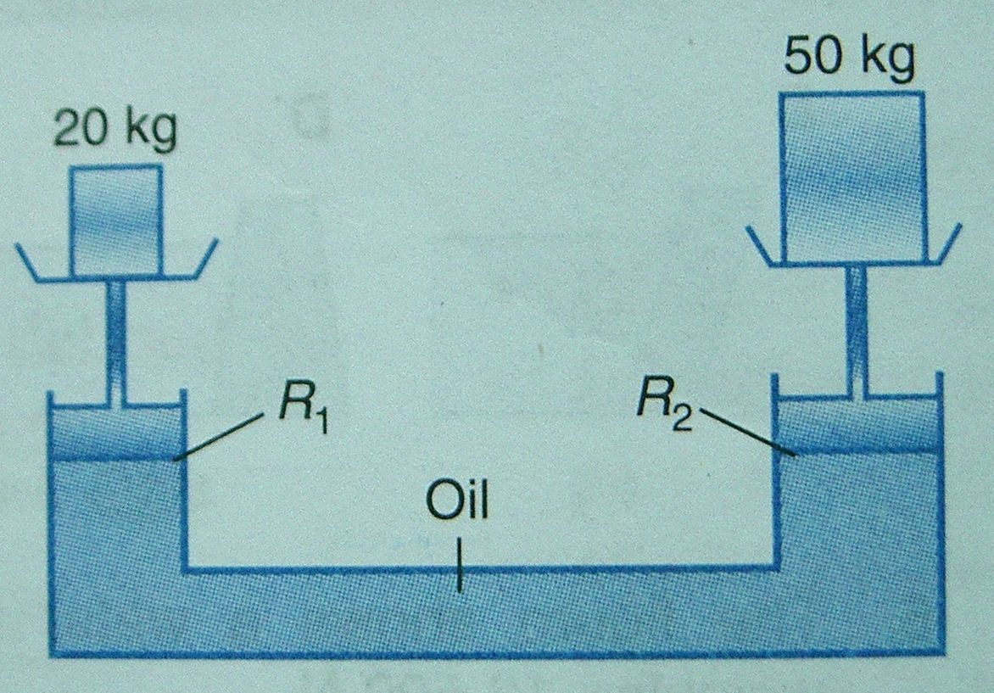

The radius of the cross-section of the smaller and the bigger piston is $R_{1}$ and $R_{2}$ respectively. The ratio of $R_{1}$: $R_{2}$ is equal to

A. 2 : 5 B. 5 : 2 C. $\sqrt{2}$ : $\sqrt{5}$ D.$\sqrt{5}$ : $\sqrt{2}$

- Based on Bernoulli’s principle, water will rise up through the tubes shown in figure.
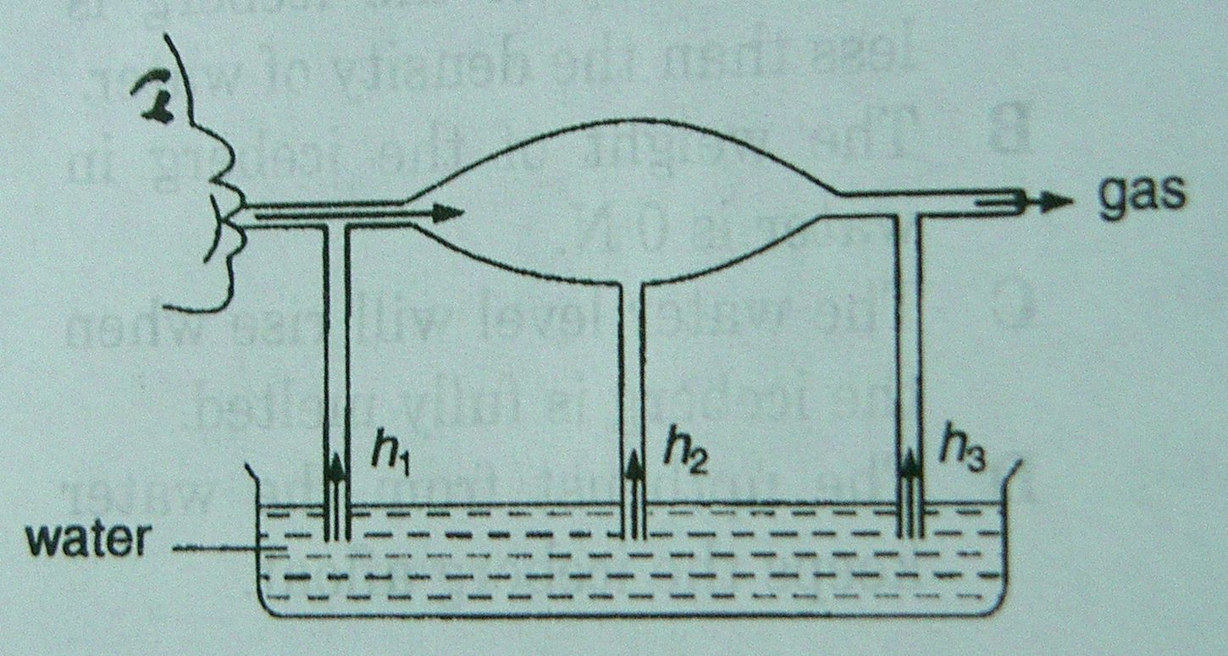

The heights of water levels in descending order is

A. $h_{1}$ $h_{3}$ $h_{2}$ C. $h_{2}$ $h_{1}$ $h_{3}$
B. $h_{3}$ $h_{1}$ $h_{2}$ D. $h_{3}$ $h_{2}$ $h_{1}$
- The energy required to change 4.0 kg of water at $\text{100}°C$ into steam at the same temperature is 9.04 MJ. What is the specific latent heat of vaporization of water?

A. 2.26 ${\text{10}}^{7}$ J ${\text{kg}}^{−1}$ C. 2.26 ${\text{10}}^{4}$J ${\text{kg}}^{−1}$
B. 2.26 ${\text{10}}^{6}$ J ${\text{kg}}^{−1}$ D. 2.26 ${\text{10}}^{3}$ J ${\text{kg}}^{−1}$

- The mass of metal X is 4 times less than the mass of metal Y. The same amount of heat is supplies to metals X and Y, resulting in an increase in temperature of metal X which is half of that of metal Y. Determine the ratio of the specific heat capacity of metal X to the specific heat capacity of metal Y.

A. 8 : 1 B. 1 : 8 C. 4 : 1 D. 1 : 4

- Figure below shows a piston in an airtight cylinder being pushed from X to Y.
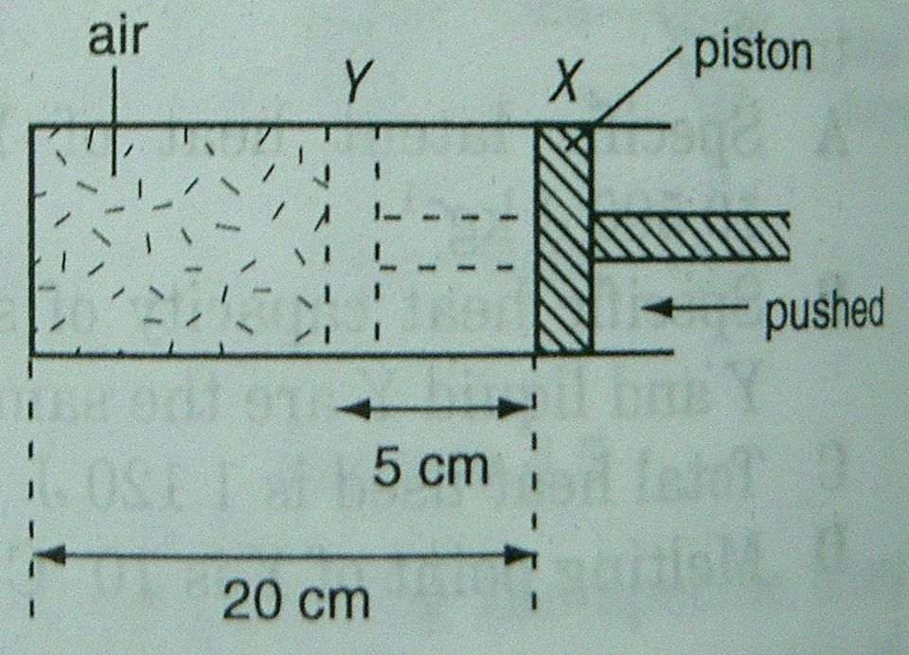

The new air pressure is increased by

A. $\frac{1}{4}$ times B. $\frac{3}{4}$ times C. $\frac{4}{3}$ times D. 4 times

- The diagram shows some air trapped in a glass tube by a column of concentrated sulphuric acid.
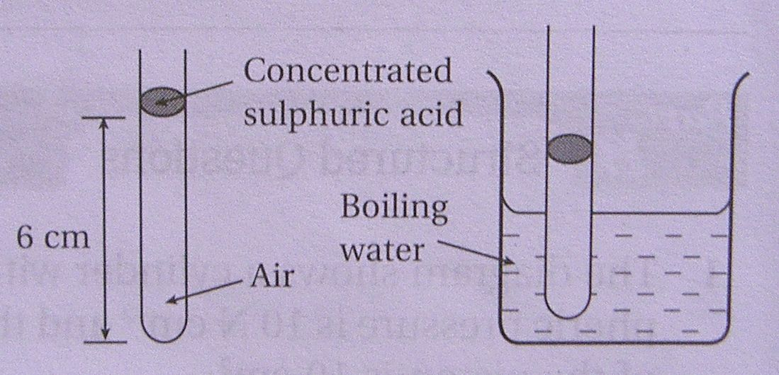

The length of the air column is 6 cm at $\text{27}°C$. What is the length of the air column when the tube is dipped into a beaker of boiling water?

A. 4.8 cm B. 7.5 cm C. 12.0 cm D. 22.2 cm

- The pressure of a gas decreases from 1.2 ${\text{10}}^{5}$Pa to 9 ${\text{10}}^{4}$Pa at 40$°C$. If the volume of the gas is constant, find the initial temperature of the gas.

A. 53$°C$ B. 144$°C$ C. 273$°C$ D. 417$°C$

- Figure shows a process in which a solid is changed to liquid at constant temperature.
SOLID
LIQUID

The heat absorbed during the process is called
  - Specific heat capacity of fusion
  - Specific heat capacity of vaporization
  - Latent heat of fusion
  - Latent heat of vaporization

- The focal length of a convex mirror is 10 cm. What are the characteristics of the image of an object placed 20 cm away from the mirror?

  - Upright, virtual and magnified
  - Upright, virtual and diminished
  - Inverted, real and same size
  - Inverted, real and magnified

- In Figure, an incident light ray SO is reflected through OQ. The mirror is rotated $5°$ to position MN. What is the angle between the first and the second reflected rays?
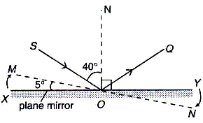

A. $5°$ B. $\text{10}°$ C. $\text{35}°$ D. $\text{45}°$

- Figure shows the refraction of a light ray from water to air. If the refractive index of water is 1.33, what is the angle of refraction $θ$?
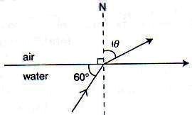

A. $\text{22}\text{.}1°$ B. $\text{40}\text{.}6°$ C. $\text{41}\text{.}7°$ D. $\text{48}\text{.}8°$
- In Figure below, u = object distance and v = image distance of a convex lens. What is the power of the lens?
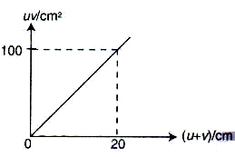

A. 0.2 D B. 5.0 D C. 20 D D. 100 D

- Two convex lenses of focal length 5 cm and 80 cm are used to assemble a simple astronomical telescope. Which of the following set-up is correct?

 | Focal length of objective lens | Focal length of  eye-piece | Distance between two lenses
A | 5 cm | 80 cm | 75 cm
B | 5 cm | 80 cm | 85 cm
C | 80 cm | 5 cm | 75 cm
D | 80 cm | 5 cm | 85 cm

Section B: Structured Question (40%)
Instruction: Answer all questions in this section.

- Diagram below shows a ticker tape, which is pulled by a trolley through a ticker timer that makes 50 dots in a second.
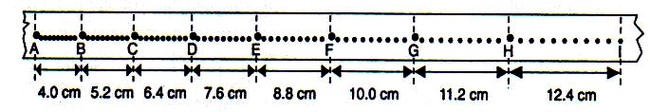

      - Name the type of electric current used for the ticker timer.

________________________________________________________ [1 mark]

      - Describe the movement of the trolley.

________________________________________________________ [1 mark]

      - Find the acceleration of the trolley.

________________________________________________________ [2 marks]

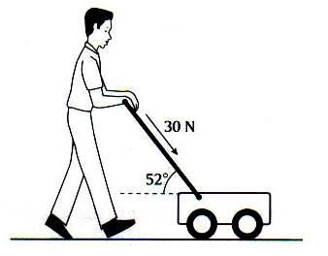
- Figure 2 show a man pushes a lawnmower of mass 5 kg with a force of 30 N along the handle of the lawnmower. The frictional between the lawnmower and the ground is 12 N.
Figure 2

      - What is the resultant force acting on the lawnmower?

________________________________________________________ [1 mark]

      - Calculate the acceleration of the lawnmower.

________________________________________________________ [2 marks]

      - Determine the normal reaction R acting on the lawnmower.

________________________________________________________ [2 marks]

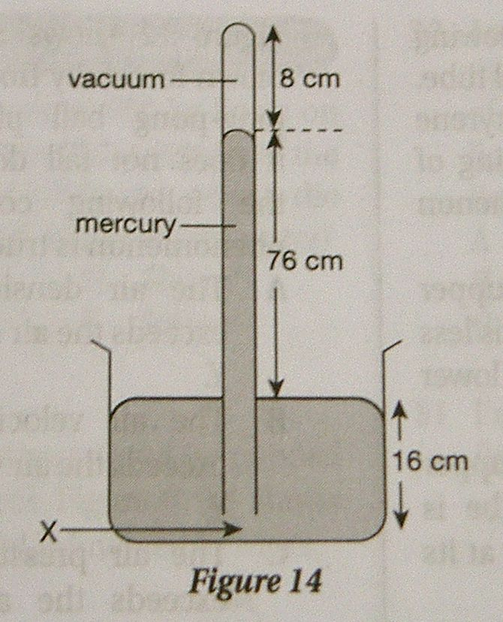
Figure 14 shows an apparatus used in the laboratory to measure atmospheric pressure. The length of the glass tube is 100 cm. The height of the vacuum column is 8 cm and the height of the mercury column is 76 cm.

    - Name the apparatus as shown in the figure.

________________________________________________________ [1 mark]

    - What is the value of the atmospheric pressure in cm Hg?

________________________________________________________ [1 mark]

(c) What is the pressure at point X in cm Hg?

________________________________________________________ [1 mark]

(d) If the density of the mercury is 1.36 ${\text{10}}^{4}$ kg $m^{−3}$ and the acceleration due to gravity is 9.8 $m$$s^{−2}$, calculate the atmospheric pressure in pascal.

________________________________________________________ [2 marks]

(c) State down two applications of Atmospheric Pressure in our daily life.

________________________________________________________ [1 mark]

________________________________________________________ [1 mark]

- Figure 4.1 shows an object, P with a density of $\text{4780}\text{kg}m^{−3}$and a mass of $\text{820}g$ supported by a spring balance. Figure 4.2 shows an object immersed totally in water and the water displaced is collected in beaker Q.
[Density of water = $\text{1000}\text{kg}m^{−3}$]
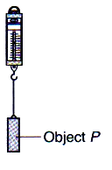
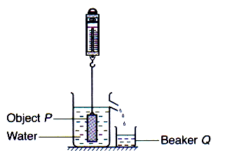
Figure 4.1
Figure 4.2

      - What is the weight of object P in Figure 4.1?

________________________________________________________ [1 mark]

      - What is the volume of the water collected in beaker Q?

________________________________________________________ [2 marks]

      - What is the weight of water collected in beaker Q?

________________________________________________________ [2 marks]

      - What is the buoyant force acting on the object?

________________________________________________________ [1 mark]

      - What is the reading of the spring balance in Figure 4.2?

________________________________________________________ [1 mark]
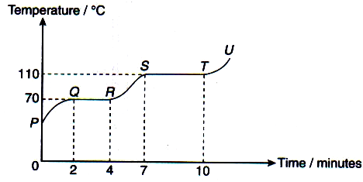
- A solid substance of mass 460 g is heated by an 80 W immersion heater. The initial temperature of the substance is $\text{20}°C$. Diagram below shows the heating curve of the substance.

      - State the phase(s) of the substance in the given sections.

- PQ : ________________________________________________ [1 mark]

(ii) QR : ________________________________________________ [1 mark]

(iii) RS : ________________________________________________ [1 mark]

      - What is the melting point of the substance?

________________________________________________________ [1 mark]

      - Explain why the temperature is constant in section YZ although the heater continues to supply energy to the substance.

________________________________________________________ [1 mark]

      - Calculate the specific heat capacity of the substance in the liquid phase.

________________________________________________________ [2 marks]

      - Calculate the specific latent heat of fusion of the substance.

________________________________________________________ [2 marks]
- Figure 6 shows three positions of a capillary tube containing a column of trapped air by a thread of mercury. The atmospheric pressure at the room temperature of $\text{28}°C$ is 76 cm Hg.
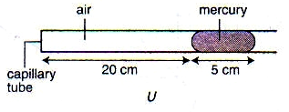
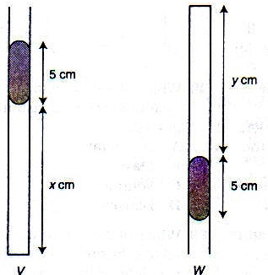
Figure 6

(a) State the pressure of the trapped air, in cm Hg, for the position in

(i) U : _________________________________________________ [1 mark]

(ii) V : _________________________________________________ [1 mark]

(ii) W : _________________________________________________ [1 mark]

(b) Calculate the value of x and y.

________________________________________________________ [4 marks]

(c) State the law used in the calculations in (b).

________________________________________________________ [1 mark]

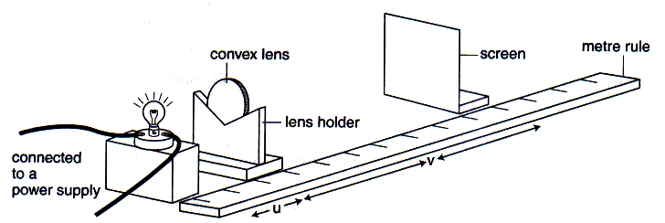
- An experiment is carried out to investigate the relationship between the object distance and the focal length of a convex lens. A bulb is lighted and the screen is adjusted until a clear image is obtained. The object and image distances are recorded in Table 7.

Object distance, u / cm | Image distance , v / cm | $${\frac{1}{u}}/{{\text{cm}}^{−1}}$$ | $${\frac{1}{v}}/{{\text{cm}}^{−1}}$$
15.0 | 30.0
20.0 | 20.0
25.0 | 16.5
30.0 | 15.0
35.0 | 13.3
40.0 | 12.8
Table 7

  - Based on the explanation on the experiment, state the

  - Manipulated Variable: ________________________________ [1 mark]

  - Responding Variable: ________________________________ [1 mark]

  - Fixed Variable: _____________________________________ [1 mark]

  - Complete Table 8 for the values of $\frac{1}{u}$ and $\frac{1}{v}$ [2 marks]

  - Use a graph paper, plot the graph $\frac{1}{v}$ against $\frac{1}{u}$. [4 marks]

  - Determine the relationship between $\frac{1}{u}$ against $\frac{1}{v}$.

_____________________________________________________ [1 mark]

  - Determine the focal length, f of the lens.

_____________________________________________________ [2 mark]

Section C: Essay Question (30%)
Instruction: Answer all questions in this section.

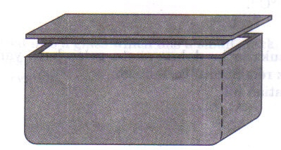
    - Figure 1 shows a food container used for keeping the food warm. The container is able to maintain the temperature of food for a long time. The container can be moved from one place to another.
Figure 1

Table 1 show the characteristics of material which could be used to make the food container.
Material | Density / $\text{kg}m^{−3}$ | Melting Point / $°C$ | Specific heat capacity / $J{\text{kg}}^{−1}°C^{−1}$ | Thermal Conductivity
P | 2710 | 660 | 910 | High
Q | 910 | 27 | 1600 | Low
R | 1050 | 1240 | 1300 | Low
S | 2600 | 1200 | 670 | Low
T | 3800 | 2020 | 800 | High
Table 1

(a) What is meant by melting point ? [1 mark]

(b) You are asked to investigate the characteristics of the materials in Table 1 which could be used to make the food container as in Figure 1.
Explain the suitability of each characteristic in Table 1 and hence, determine which material is most suitable to be used to make the food container.
Justify you choice. [10 marks]
(c) 500 g of hot water at $\text{90}°C$is poured into a glass and left to cool down to room temperature at $\text{30}°C$.

(i) Sketch the temperature – time graph for the cooling process of the hot water. Use your graph to explain this process. [4 marks]

(ii) Calculate the quantity of heat lost from the hot water. The specific heat capacity of water 4 200 $J{\text{kg}}^{−1}°C^{−1}$. [2 marks]

(iii) Hot water is poured into a glass which has small crack. It is observed that the size of the crack increases. Explain this observation. [3 marks]

    - In Figure 2(a) and (b), two springs with the same elastic constant are oscillating with babies of different masses. Even though the amplitude of oscillation is kept constant, the period of oscillation for the two babies is different.
Based on the observations,
(a) state one suitable inference that can be made. [1 mark]
(b) state one appropriate hypothesis for this investigation. [1 mark]
(c) With the use of appropriate apparatus, describe an experimental framework to test your hypothesis. In your description, state clearly the following:
(i) Aim of the experiment
(ii) Variables involved in the experiment
(iii) List of apparatus and material
(iv) Arrangement of the apparatus
(v) The procedure of the experiment which include the method of controlling the manipulated variables and the method of measuring the responding variable
(vi) Way you would tabulate the data
(vii)Way you would analyse the data [10 marks]

Answer:
Section A

Section B:
1.
2. (a) Horizontal: Resultant force = $\text{30}\text{cos}\text{52}°−\text{12}=6\text{.}5N$ [1 m]
    - Horizontally: $F=\text{ma}$
$6\text{.}5=5×a$ [1 m]
$∴a=1\text{.}3{ms}^{−1}$ [1 m]
    - Vertically: $R=\text{mg}+\text{30}\text{sin}\text{52}°$ [1 m]
$R=\text{50}+\text{23}\text{.}6=\text{73}\text{.}6N$ [1 m]
3. (a) Simple mercury barometer [1 m]
(b) 76 cm Hg [1 m]
(c) 76 cm Hg + 16 cm Hg = 92 cm Hg [1 m]
(d) Atmospheric pressure = $ρ$h g = $\left(1\text{.}\text{36}×{\text{10}}^{4}\right)\left(0\text{.}\text{76}\right)\left(9\text{.}8\right)$ [1 m]
= 1.01 ${\text{10}}^{5}$ Pa [1 m]
(e) Rubber suction cups // plastic sticker // condensed milk is being poured out of its can // the siphon // the bicycle pump // the lift pump // the force pump // the syringe // the plunger // the vacuum cleaner [2 m]

4. (a) Weight = mg = $0\text{.}\text{820}×\text{10}=8\text{.}\text{20}N$
(b) Volume of water displaced = $\frac{m}{ρ}=\frac{0\text{.}\text{820}}{\text{4780}}=1\text{.}\text{72}×{\text{10}}^{−4}m^{−3}$
(c) Weight of water displaced
= $Vρg=1\text{.}\text{72}×{\text{10}}^{−4}×\text{1000}×\text{10}=1\text{.}\text{72}N$
(d) Buoyant force = $1\text{.}\text{72}N$
(e) Reading on spring balance = $8\text{.}\text{20}N−1\text{.}\text{72}N=6\text{.}\text{48}N$
5. (a) (i) Solid [1 mark]
(ii) Solid and liquid [1 mark]
(iii) Liquid [1 mark]
(b) $\text{67}°C$ [1 mark]
(c) Because the energy supplied to the substance is used to break up the
bond between the molecules. [1 mark]
(d) $\text{Pt}=\text{mc}θ$
$\text{80}×2×\text{60}=0\text{.}\text{46}×c×\left(\text{90}−\text{67}\right)$ [1 mark]
$c=\text{907}J{\text{kg}}^{−1}°C^{−1}$ [1 mark]
(e) $\text{Pt}=\text{ml}$
$\text{80}×6×\text{60}=0\text{.}\text{46}×l$ [1 mark]
$l=6\text{.}\text{26}×{\text{10}}^{4}J{\text{kg}}^{−1}$ [1 mark]

6. (a) (i) 76 cm Hg
(ii) 81 cm Hg
(iii) 71 cm Hg
(b) $P_{1}V_{1}=P_{2}V_{2}$
$\text{76}×\text{20}=\text{81}×x$ $x=\frac{\text{76}×\text{20}}{\text{81}}=\text{18}\text{.}\text{77}\text{cm}$
$\text{76}×\text{20}=\text{71}×y$ $y=\frac{\text{76}×\text{20}}{\text{71}}=\text{21}\text{.}\text{41}\text{cm}$
(c) Boyle’s law

7. (a) (i) Object distance
(ii) Imgae distance
(iii) Type of convex lens used
(b)
Object distance, u / cm | Image distance , v / cm | $${\frac{1}{u}}/{{\text{cm}}^{−1}}$$ | $${\frac{1}{v}}/{{\text{cm}}^{−1}}$$
15.0 | 30.0 | 0.067 | 0.033
20.0 | 20.0 | 0.050 | 0.050
25.0 | 16.5 | 0.040 | 0.061
30.0 | 15.0 | 0.033 | 0.067
35.0 | 13.3 | 0.025 | 0.075
40.0 | 12.8 | 0.022 | 0.078

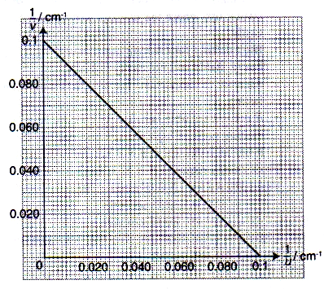
(c)

(d) $\frac{1}{v}$ is decreasing linearly to $\frac{1}{u}$
(e) $y−$intercept = $\frac{1}{f}$ $f=\frac{1}{0\text{.}1}=\text{10}\text{cm}$

Section C:
1.
- The melting point is a fixed temperature when a solid melts into a liquid.
Characteristic |  | Reason
Density | Low | It can be carried anywhere
Melting point | High | To prevent it from melting when hot food is stored into it.
Specific heat capacity | High | Enable to dissipate heat quickly.
Thermal conductivity | Low | Ensure heat is not lost easily and the food will remain hot.

Material R is the most suitable material to make the food container as it is light in weight, has a high melting point, high specific heat capacity and low in thermal conductivity.
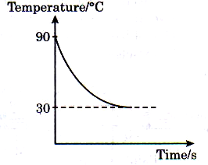
- (i)

When poured into a glass, heat from hot water at $\text{90}°C$is released to the surroundings. When thermal equilibrium is achieved, the final temperature is $\text{30}°C$.
(ii) Quantity of water released by the hot water,
Q = $mcθ$ = $0\text{.}5×\text{4200}×(\text{90}−\text{30})=1\text{.}\text{26}×{\text{10}}^{5}J$
(iii) In the cracked region, there are atoms missing. Thus, the strength of glass is reduced. The separation between the atoms will increase as a result of expansion of the glass when hot water is poured into it.

2. (a) The extension of the spring depends on the weight or force acting on it.
(b) The extension of the spring is directly proportional to the stretching force.
(c) (i) To investigate the relationship between the extension of a spring and the stretching force.
(ii) Variable: Manipulated: Weight of load, F
Responding: Spring extension, x
Fixed: Force constant of the spring, k
(iii) Apparatus / Material: Spring, pin, slotted weight, weight holder, retort stand with clamp, metre rule, and plasticine.
(iv)
(v) Procedure:
- The metre rule is clamped vertically to the retort stand, with its ‘O’ mark at the top.
- The spring is suspended from the clamp.
- The pin is attached to the bottom end of the spring with plasticine.
- The initial position of the pin, $l_{ο}$ is noted.
- A weight holder of mass 50 g is hooked onto the bottom of the spring.
- The new position of the pin, l is recorded.
- The extension of the spring is calculated from the formula: $x=l−l_{ο}$.
- The experiment was repeated with the addition of 50 g each time until a maximum of 300 g. All the respective readings are noted and recorded.
(vi)
Weight of load, W | Stretching Force, F=mg | Spring extension, $x=l−l_{ο}$
50
100
150
200
250
300

(vii)

