1(a) Write the formula for density.
______________________________________________________________
( 1 mark)
(b) Calculate the following and show your working in the spaces provided.
i) A piece of glass has a mass of 10g and its volume is 4 cm3. What is the
density of glass?

______________________________________________________________
( 2 marks)
(c) Label Figure 1 below correctly based on the density of each of the following
substances on the spaces beside (a), (b) and (c).
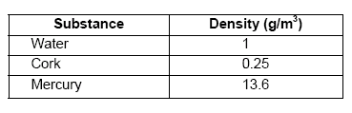
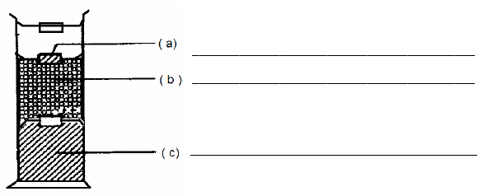
Figure 1

2. Figure 2 below shows set of apparatus for an experiment. The iron filings and the sulphur powder are mixed thoroughly.
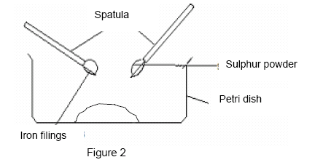
( a ) What will happen if a bar magnet is brought near the petri dish?
_________________________________________________________( 1 mark )
( b ) Is the substance in the petri dish a mixture or a compound ?
_________________________________________________________( 1 mark )
( c ) If the mixture of iron filings and sulphur powder heat strongly, what is the new substance form?
__________________________________________________________( 1 mark )
( d ) Can the new substance attract by the bar magnet? Why?
____________________________________________________________
_____________________________________________________________( 2 marks )
( e ) State the physical method you would use to separate the following mixtures.
(i) A mixture containing iron filings and sulphur powder.
__________________________________________________________( 1 mark )
(ii) A mixture containing water and chalk powder.
__________________________________________________________( 1 mark )

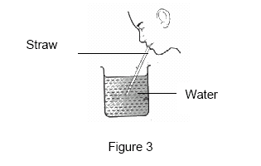
3. Figure 3 above shows a student sipping water from a beaker using a straw.
(a) When the student sucks on the straw, what will happen to the air in thestraw ?
________________________________________________________
________________________________________________________( 1 mark )
(b) What happens to the air pressure inside the straw ?
__________________________________________________________( 1 mark )
(c) Compare the air pressure inside and outside the straw
_____________________________________________________________( 1 mark )
(d) If there is a hole in the side of the straw, what will happen? Why?
________________________________________________________
________________________________________________________
________________________________________________________( 2 marks )
(e) Name two examples of devices that operate based on a difference in airpressure.
__________________________________________________________
__________________________________________________________( 2 marks )

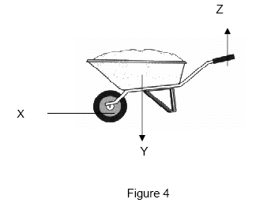

4. Figure 4 above shows a wheelbarrow as a simple machine.
(a) What class of lever is the wheelbarrow ?
____________________________________________________________( 1 mark )
(b) What is the advantage of that class of lever ?
____________________________________________________________( 1 mark )
(c) What is represented by X , Y and Z ?
X : _________________________________________________________
Y : _________________________________________________________
Z :__________________________________________________________( 3 marks )
(d) Name two other devices that operate base on that class of lever ?
____________________________________________________________
____________________________________________________________( 2 marks )

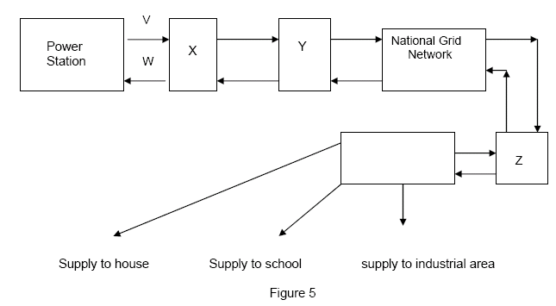
5. Figure 5 above shows the transmission and distribution of electricity from the power station to the consumers.
( a ) Name the wire labeled
( i ) V :___________________________________________________________
( ii ) W :-__________________________________________________________( 2 marks )
( b ) Name X, Y and Z
( i ) X __________________________________________________________
( ii ) Y:__________________________________________________________
( iii ) Z :_________________________________________________________( 3 marks )
( c ) What is the function of Y ?
________________________________________________________________( 1 marks )
( d ) Give one advantage of National Grid Network.
_____________________________________________________________
_____________________________________________________________( 1 mark )

6. Figure 6 shows the stages in the formation and the death of a body in the Universe.
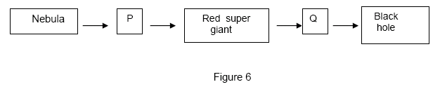
( a ) What is represented by P and Q ?
P : _________________________________________________________
Q : _________________________________________________________
( 2 marks )
( b ) How energy is generated by P ?
____________________________________________________________
____________________________________________________________
( 1 mark )
( c ) State two types of energy released following the reaction in (b).
____________________________________________________________
____________________________________________________________
( 2 marks)
( d ) What happens to all objects when the objects go near the black hole?
_____________________________________________________________
( 1 mark )

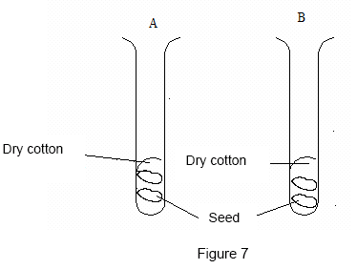
7. Figure 7 above shows a set of apparatus to study the conditions for the germination of seeds . The activity is set for three days.
( a ) State the function for test tube A.
_______________________________________________________________( 1 mark )
( b ) State the variable that
( i ) is manipulated
___________________________________________________________( 1 mark )
( ii ) is kept constant
___________________________________________________________( 1 mark )
( iii ) responds
___________________________________________________________( 1 mark )
(c ) What is the relation of the manipulated variable and the responding variable for the activity ?
_______________________________________________________________( 1 mark )

( d ) The seeds will germinate in which test tube ?
_______________________________________________________________( 1 mark )
( e ) Give the inference for your answer in ( d ).
_______________________________________________________________( 1 mark )
( f ) State three factors that are needed for the seeds to germinate .
_______________________________________________________________
_______________________________________________________________
______________________________________________________________( 3 marks )

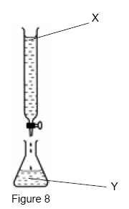
8. Figure 8 above shows the titration method.
( a) What is neutralisation?
___________________________________________________________( 1 mark )
( b) Write word equation of neutralisation.

___________________________________________________________
(c ) Identify solution X and Y ( acid or alkali)
X: ________________________ Y: _________________________( 2 marks)
( d ) Give one example of solutions X and Y.
X: __________________________________________________________
Y: __________________________________________________________( 2 marks )
( e ) To which solution is the indicator added?
______________________________________________________________( 1 mark )
( f ) What is the pH value of the product of the neutralisation in Figure 8?
______________________________________________________________( 1 mark )
( g ) Give two application of neutralisation in daily life.
( i ) ___________________________________________________________
( ii ) ___________________________________________________________( 2 marks )

Answer:

1. a) Density = Mass
--------------
Volume
b) 10 g
----------
4 cm ³
= 2.5 g / cm ³
c ) a ) cork
b ) water
c ) mercury

2. a ) The bar magnet will attract the iron filings and the sulphur powder will be left in the petri dish
b ) It is a mixture
c) Compound
d) Cannot.
There is no effect on the compound because the elements cannot be separated by physical means.
c ) i ) using a magnet
ii ) filtration

3. a ) The air in the straw is removed
b ) The pressure of the air in the straw is decreases
c ) The air pressure inside the straw is lower than the air pressure outside the straw
d) The water cannot travel up the straw. This is because the pressure inside the straw and the atmospheric pressure outside are the same.
e ) Syringe, Siphon , Spray, Dropper , Filter pump

4. a) second class lever
b) The effort used is less than the load
c )
X : fulcrum
Y : load
Z : effort
d) bottle opener
paper cutter
nut cracker

5. a) i) V : live wire
ii) W: neutral wire
b) i) X step-up transformer
ii) Y switch zone
iii) Z step-down transformer
c) to connect or disconnect circuit
d) If one of the power stations breaks down, its function can be taken over by the other station.

6. a) P : medium-size star
Q : planetary nebul a
b) by nuclear fussion of hydrogen atoms
c) Heat energy
Light energy
d) All objects near it are pulled towards it.

7.
a ) As a control
b ) i ) Presence of water
ii ) Type of seed / suitable temperature
iii ) Germination of seed
c ) The presence of water is needed for the germination of a seed.
d ) Test tube B.
e ) The seeds get water from the wet cotton that is required for the germination.
f ) Air
Water
The suitable temperature

8.
a ) Neutralisation is a process of which acid and alkali react to form salt and water.
b) Acid + Alkali Salt + Water
c ) X : Acid
Y : Allkali
d ) X : Dilute hydrochloric acid / Dilute sulphuric acid
Y Sodium hydroxide / Potassium hydroxide / Ammonia solution
e ) Y / Alkali
f ) pH 7
e ) The alkali in toothpaste neutralizes the acid on the teeth.
The acid in hair conditioners neutralizes the alkali in shampoos.
Antacids which are alkali is used to treat stomach upset.

